The App-Owns-Data Multitenant Application

The **AppOwnsDataMultiTenant** application is a sample .NET 6 application which demonstrates how to design an App-Owns-data application using the **service principal profiles** feature introduced in the Power BI Service in March of 2022. This article explains how service principal profiles can be used to design and implement a large-scale, multitenant environment for Power BI embedding with 10,000's or 100,000's of customer tenants.

This article will began with a quick primer on developing multitenant application using App-Owns-Data embedding. This primer will allow the reader to better understand **the** problems that service principal profiles were created to solve. Next, this article will introduce service principal profiles and explain how they can be used to improve performance, scalability and security in a multitenant application that has been developed using App-Owns-Data embedding.

The article also contains step-by-step instructions to set up the **AppOwnsDataMultiTenant** application to get it up and running in a Power BI development environment.

Published March 31, 2022

Table of Contents

Developing Multitenant Applications with Power BI Embedding 2

Understanding the 1000 Workspace Limitation 2

Managing Isolation for Datasets and Datasource Credentials 3

Design Strategies Before Service Principal Profiles 4

Introduction to Service Principal Profiles 5

Service Principal Profiles as First-class Power BI Security Principals 5

Executing Power BI REST API Calls as a Service Principal Profile 6

Using the Profiles API to create and manage service principal profiles 7

Executing API Calls Under the Identity of a Service Principal Profile 9

Getting Started with the **AppOwnsDataMultiTenant** application 11

Setting up your development environment 12

Create an Azure AD security group named Power BI Apps 12

Configure Power BI tenant-level settings for service principal profile access 13

Create the Azure AD Application for the AppOwnsDataMultiTenant Application 17

Add the Azure AD Application to the Power BI Apps Group 21

Set Up the AppOwnsDataMultiTenant Application in Visual Studio 2022 22

Download the Source Code 22

Open the Project in Visual Studio 2022 22

Update application settings in the appsettings.json file 23

Create the AppOwnsDataMultiTenantDB database 24

Test the AppOwnsDataMultiTenant Application 28

Create New Customer Tenants 28

Embed Reports 32

Inspect the Power BI Workspaces 34

Create Multiple Workspaces with a Single Service Principal Profile 37

## Developing Multitenant Applications with Power BI Embedding

If you have experience working with Azure AD, the word **"tenant"** might make you think of an Azure AD tenant. However, the concept of a tenant is different when talking about building a multitenant environment for Power BI embedding. In this context, each tenant is created on behalf of a customer for which you are embedding Power BI reports using the App-Owns-Data embedding model. Each customer tenant is typically implemented using a single Power BI workspace.

In order to create a scalable multitenant environment, you must be able to automate the creation of new customer tenants. Provisioning a new customer tenant typically involves writing code which calls the Power BI REST API to create a new Power BI workspace, import PBIX files, update datasource parameters, set datasource credentials and start dataset refresh operations. The following diagram depicts how Power BI artifacts such as reports and datasets can be added into workspaces to create customer tenants.

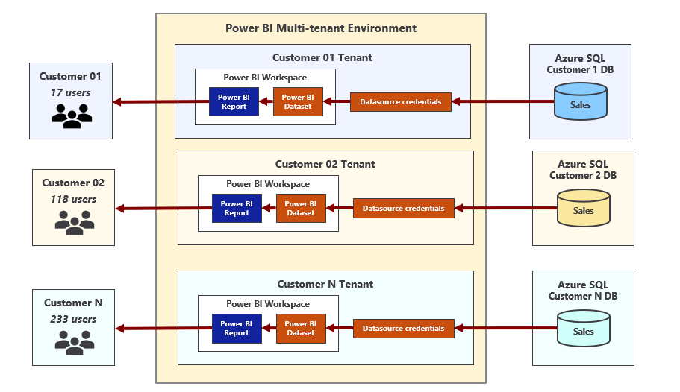

When developing an application that implements App-Owns-Data embedding, it’s possible to call the Power BI REST API under the identity of a master user account or under the identity of a service principal. However, Microsoft strongly recommends using a service principal. By using a service principal, you can avoid common problems associated with master user accounts such as experiencing authentication errors in environments where users are required to log in using multi-factor authentication (MFA). Using a service principal is also consistent with the idea that App-Owns-Data embedding is based on leveraging the Power BI Service using a Platform-as-a-Service (PaaS) mindset as opposed to a Software-as-a-Service (SaaS) mindset.

### Understanding the 1000 Workspace Limitation

When designing a multitenant environment for App-Owns-Data embedding, there is a documented limitation that requires your attention. In particular, the limitation is that neither a user nor a service principal can be member of more than 1000 workspaces. The purpose of this limitation has to do with performance. The limitation exists to ensure code paths don't become inefficient resulting in performance degradation. At little background might make it easier for you to understand what's involved.

Behind the scenes, the Power BI Service maintains a set of security-related metadata for each service principal. The Power BI Service uses this metadata to track which workspaces and artifacts the service principal can access. In effect, the Power BI Service maintains a separate access control list (ACL) for each service principal as part of its authorization subsystem.

When a service principal calls the Power BI REST API to access a workspace, the Power BI service runs an security check against the service principal's ACL to ensure it has the proper authorization. As you can imagine, the time it takes to determine whether the target workspace ID is inside the ACL increases as the number of workspaces increases. The Power BI team created and documented the 1000-workspace limitation to ensure the authorization metadata (i.e. ACL) for a service principal (or user) doesn't grow so large that it significantly degrades performance.

The 1000-workspace limitation isn’t enforced through code in the Power BI Service. If you try, you'll find you can create 1,200 workspaces using a single service principal. When you cross over the line from 1000 to 1001 workspaces, nothing really changes. Calls from the service principal to the Power BI REST API will still execute successfully. However, it's important to acknowledge that the application has moved into an "unsupported" state which has implications when trying to get help from Microsoft support.

To summarize, the scenario in which a service principal owns 1000 workspaces or less is supported. The scenario in which a service principal owns 1001 workspaces or more is unsupported. However, that's not the end of the story. Let's look at a simple example to make an important point.

Consider a scenario in which two multi-tenant applications have each been implemented to use a single service principal. Now imagine the first application has created 990 workspaces while the second application has created 1010 workspaces. From a supportability standpoint, the first application is within the supported boundaries while the second application is not.

Now let's compare these two applications purely from a performance point of view. There's really not that much difference because the ACLs for both service principals have let the metadata for their ACLs grow to a point where it will degrade performance to some degree.

Here's the key observation. The number of workspaces created by a service principal has a direct effect on performance. A service principal which is a member of 100 workspaces will execute calls on the Power BI REST API faster than a service principal which is a member of 1000 workspaces. Likewise, a service principal which is a member of only 10 workspaces will execute calls faster than a service principal which is a member of 100 workspaces. From the perspective of performance and scalability, the optimal number of workspaces in which a service principal should be a member is 1.

### Managing Isolation for Datasets and Datasource Credentials

Another important aspect of designing an App-Owns-Data embedding application for a multitenant environment has to do with maintaining the required level of isolation across customer tenants. The last thing you want is for a user from one customer tenant to see data from another tenant that belongs to a different customer. Therefore, it's critical that you understand how datasets and datasource credentials are managed within the Power BI Service.

Each dataset in the Power BI Service has an owner which can be either a user or a service principal. You can discover who the dataset owner is by inspecting the **ConfiguredBy** property in the dataset settings page. If it's ever required, you can perform a Take Over action to transfer dataset ownership from one user or service principal to another. If you import a PBIX file to create a new dataset using a service principal, the service principal is automatically configured as the dataset owner.

In order to connect a dataset to its underlying datasource, the dataset owner must set dataset credentials. These datasource credentials are then cached by the Power BI Service in an encrypted fashion. After that point, the Power BI Service is then able to use those credentials to authenticate with the underlying datasource when refreshing the data in an import-mode dataset or when executing a query with a DirectQuery dataset.

There is a common pattern used by developers when provisioning a new customer tenant where the application executes a series of calls all running as a service principal. The first call creates a new workspace. The second call associates that workspace with a dedicated capacity. Next, there is a call to import a PBIX file to create a new dataset. After importing a PBIX file to create a dataset, a service principal can then set the dataset source credentials for that dataset. As a result of these Power BI REST API calls, the service principal is an Admin of the new workspace and the owner of the dataset and the datasource credentials.

A common misconception is that datasource credentials in the Power BI Service are scoped at the workspace level. They are not. Instead, datasource credentials are scoped by user or by service principal and their scope extends across all Power BI workspaces in the current Azure AD tenant. It's possible for a service principal to create datasource credentials that are used by datasets in different workspaces as shown in the following diagram.

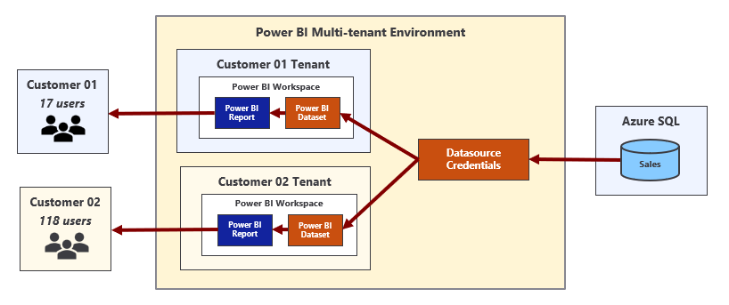

### Design Strategies Before Service Principal Profiles

In this section, we will quickly review the three common design strategies that have been used to build and manage multitenant environments for App-Owns-Data embedding. This will give you a better appreciation of the design problems that service principal profiles have been designed to solve.

Prior to the introduction of service principal profiles, developers have built multitenant applications with support for App-Owns-Data embedding using one the following three design strategies.

* Single service principal
* Service principal pooling
* One service principal per workspace

Now let's review the strengths and weakness of each of these design strategies starting with single service principal. When an application is designed to use a single service principal, it requires a one-time creation of Azure AD application for service principal. Therefore, it requires less administrative overhead than the other two strategies because there is no ongoing need to create new Azure AD applications in order to add more service principals. It is also the easiest strategy to implement as the other two strategies require extra code to switch the calling context between service principals when calling the Power BI REST API.

The obvious problem with the single service principal design strategy is it doesn't scale. It only supports a multitenant environment that can grow to no larger than 1000 workspaces. The application will also be less performant as the service principal becomes a member of a large number of workspaces. Finally, there is a problem with customer tenant isolation because there is a single service principal that will be the owner of every dataset and all data credentials across all customer tenants.

Service principal pooling provides a commonly-used strategy to get around the 1000-workspace limitation. The main idea is that the application can scale to any number of required workspaces by adding the correct number of service principals to the pool. For example, a pool of 5 service principals makes it possible to scale up to 5,000 workspaces. A pool of 80 service principals makes it possible to scale up to 80,000 workspaces.

While service principal pooling can scale to a large number of workspaces, it has several disadvantages. First, it requires extra code and metadata to implement context switching between service principals when calling the Power BI REST API. Second, there is more administrative overhead as it will be necessary to create new Azure AD applications whenever it's necessary to increase the number of the service principals in the pool.

The service principal pooling strategy is not optimized for performance because it allows service principals to become members of 100s of workspaces. It also is not ideal from the perspective of customer tenant isolation. While it's slightly better than the single service principal strategy, there is still the issue where each service principal will the owner of datasets and datasource credentials across many different customer tenants which compromises isolation.

The final strategy is the one that involves creating a new service principal for each new customer tenant. From a theoretical standpoint, this is the best solution because it optimizes the performance of calls to the Power BI REST API while also providing true isolation for datasets and datasource credentials at the workspace level. However, what works best in theory doesn't always work best in practice. This is a good example.

The strategy of creating a new service principal for each new customer tenant is impractical for most large organizations. That's because these organizations require formal approval processes or they introduce other bureaucratic red tape for creating new Azure AD applications. This makes it impossible to grant a custom application the authority it needs to create new Azure AD applications on-demand in an automated fashion which is a requirement when using this strategy.

In less-common scenarios where a custom application is granted the proper permissions, it can use the Microsoft Graph API to create new Azure AD applications on demand. This type of custom application becomes more complex to develop and deploy because it must somehow track credentials for each Azure AD application and gain access to those credentials whenever it needs to authenticate and acquire access tokens for individual service principals. The [TenantManagement](https://github.com/PowerBiDevCamp/TenantManagement) sample application demonstrates using this approach.

## Introduction to Service Principal Profiles

The previous section discussed three essential problems that need to be addressed when developing a multitenant application that uses App-Owns-Data embedding. Here is a summary of those three problems.

1. Scaling to a large number of workspaces
2. Optimizing performance in calls to the Power BI REST API
3. Isolating datasets and datasource credentials at the customer tenant level.

The Power BI embedding team created the service principal profiles feature to solve these three problems with the lowest amount of developer effort and overhead. As you will see, designing a multitenant application using service principal profiles will combine the strengths of the three design strategies discussed in the previous section while avoiding the weaknesses. Now it's time to drill down into a discussion about how service principal profiles work.

Service principal profiles are local accounts which are created within the context of the Power BI Service. A service principal can use the new [Profiles](https://docs.microsoft.com/en-us/rest/api/power-bi/profiles) endpoint of the Power BI REST API to create new service principal profiles. This makes it possible for a service principal to create and managed its own set of service principal profiles for a custom application as shown in the following diagram.

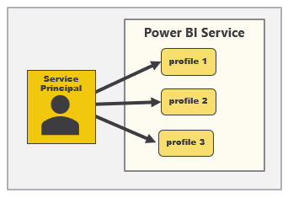

Later in this article, you will learn how to write code to create service principal profiles as well as how to execute Power BI REST API calls under the identity of a service principal profile. However, it's now time to make a general observation. While the service principal itself and its underlying Azure AD application are known to Azure AD, Azure AD doesn't know anything about service principal profiles. Instead, service principal profiles are created by the Power BI Service and they only exist within the context of the Power BI Service subsystem which controls security and authorization.

There will always be a parent-child relationship between a service principal and the service principal profiles it creates. A service principal profile can never be created as a stand-alone entity. Instead, each service principal profile must be created by specific service principal and that service principal will serve as the profile's parent. Furthermore, a service principal is never visible to users or other service principals. A service principal profile can only be seen and used by the service principal that created it.

### Service Principal Profiles as First-class Power BI Security Principals

The second important observation is that a service principal profile is first-class security principal in the Power BI authorization system. The Power BI Service treats a service principal profile like a user or a service principal in the sense that a profile can be added to a workspace as a member. A service principal profiles can also be the owner of a dataset and the owner of datasource credentials. This leads to the best practice of creating a new service principal profile for each new customer tenant as shown in the following diagram.

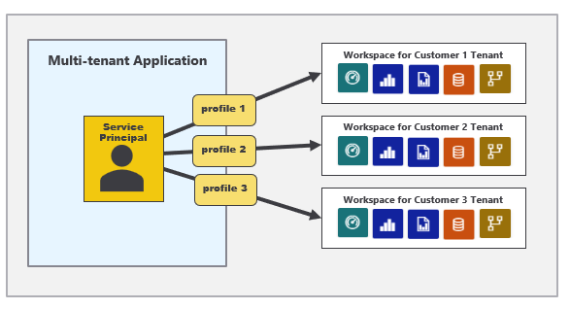

When you develop a custom application using service principal profiles, you only need a single Azure AD application which provides your application with a single service principal. This lowers administrative overhead compared to previous strategies because there is no ongoing need to create additional Azure AD applications after the application goes into production.

### Executing Power BI REST API Calls as a Service Principal Profile

You can execute Power BI REST API calls under the identity of a service principal profile. That means you can execute the sequence of API calls under the identity of a service principal profile when provisioning a new customer tenant. Let's examine this idea in a little more detail.

If you execute a Power BI REST API call under the identity of a service principal profile to create a new workspace, that profile will automatically be configured as a workspace member in the role of Admin. If you execute a call under the identity of a service principal profile to import a PBIX file and create a dataset, that profile will be configured as the dataset owner. If you execute call under the identity of a service principal profile to set datasource credentials, the profile will be configured as the owner of the datasource credentials.

Programming with service principal profiles might seem a little complicated at first. You can execute API calls under the identity of a service principal profile and you can also execute API calls without a profile which execute under the identity of the parent service principal. It's important to understand that a service principal has an identity in the Power BI Service that is separate and distinct from the identities of its profiles.

Now let's discuss a common programming pattern when developing a multitenant application using service principal profiles. Start by asking yourself this question. When do you execute Power BI REST API calls as the parent service principal versus when do you execute API calls a child service principal profile? It turns out this isn’t too complicated once you understand the basic programming pattern.

You should execute API calls as the parent service principal when you are creating, viewing and deleting service principal profiles. However, most of the other API calls should be executed as a service principal profile. This includes API calls to create workspaces and import PBIX files. It also includes API calls to update dataset parameters and to set datasource credentials. Finally, it includes API calls to query for workspace artifacts and to generate embed tokens.

Let's walk through a simple example. Imagine you need to create a new customer tenant for a customer named Wingtip. The first step is to execute an API call to create a new service principal profile with a display name of Wingtip. That first call is made under the identity of the service principal. However, all the remaining Power BI REST API calls shown in the following list should be made under the identity of the service principal profile that has just been created.

* Create workspace
* Associated workspace with capacity
* Import PBIX
* Update dataset parameters
* Set credentials
* Start refresh

Now, let's make one final observation. Each customer tenant is built using a Power BI workspace and a set of artifacts that are all owned and managed by one specific service principal profile. In order to access that Power BI workspace and its content at a later time, you must execute API calls using the identity of the same service principal profile that was used to create the customer tenant.

And what about the service principal itself? Does the service principal require any access to the workspaces for customer tenants and the content inside? The answer is no, the service principal itself doesn't need any access at all. Remember, Power BI REST API calls executed under the identity of the service principal are mainly to create and manage service principal profiles. All workspace creation and content access is done using service principal profiles.

### Using the Profiles API to create and manage service principal profiles

The Power BI embedding team has introduced a new **Profiles** API which is used to create and manage service principal profiles. You can find the documentation for the **Profiles** API at the following URL.

**https://docs.microsoft.com/en-us/rest/api/power-bi/profiles**

The Profiles API contains the following operations.

* Create Profile
* Delete Profile
* Get Profile
* Get Profiles
* Update Profile

Let's begin by looking at the Create Profile operation. The following table shows the details required for executing an HTTP POST request against the **Profiles** endpoint to create a new service principal profile.

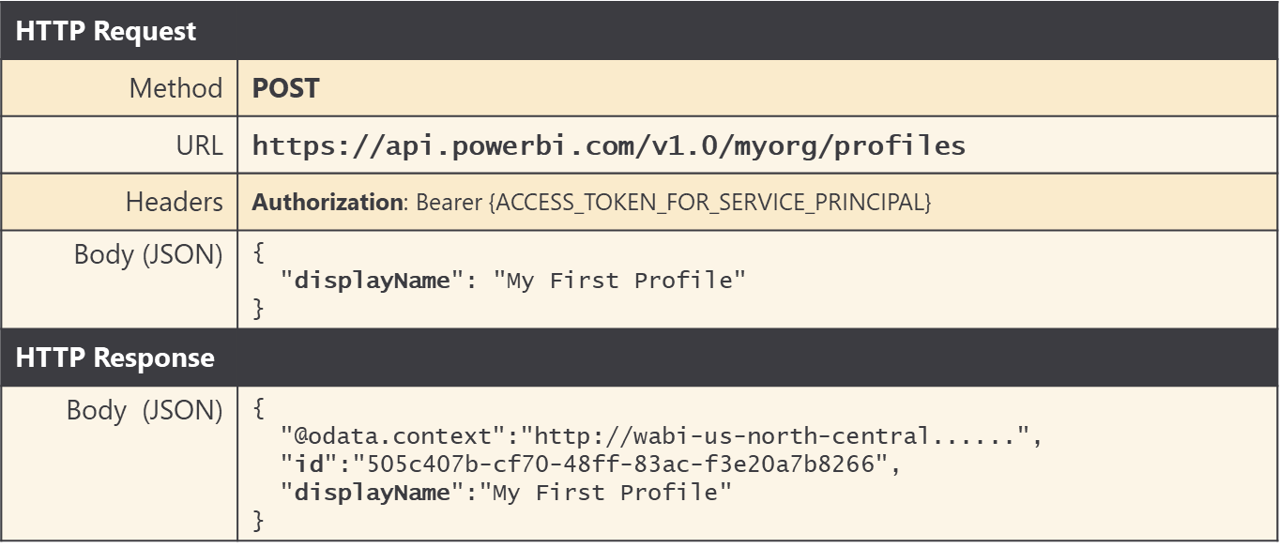

Note that you must pass a **displayName** property in the request body to provide a display name for the new tenant. The **displayName** must be unique across all the profiles owned by a specific service principal.

The API call to create a new service principal profile returns an **id** property with a GUID which represents the profile id. When developing applications that use service principal profiles, it's a best practice to store profile display names and ids in a custom database so the application can lookup the id for a service principal profile whenever it's required.

If you are programming with the Power BI .NET SDK, you can call **Profile.CreateProfile** which returns a new **ServicePrinicpalProfile** object which makes it possible to discover the **id** property value of the new profile.

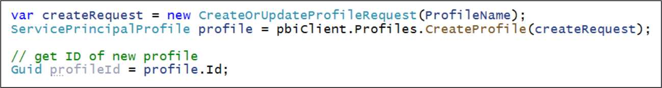

When you need to delete a service principal profile, you can execute an HTTP DELETE operation in which the profile id is parsed into the end of the URL.

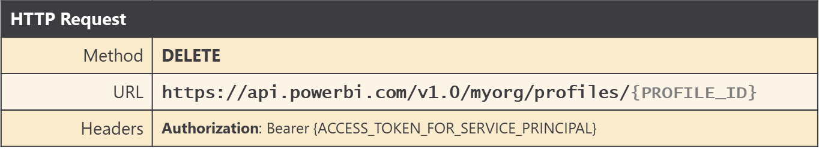

If you are programming with the Power BI .NET SDK, you can call **Profile.DeleteProfile** using the following code.



If you need to query the set of service principal profiles associated with the current service principal, you can execute an HTTP GET operation against the **Profiles** endpoint. This API calls returns a JSON payload with the **id** and **displayName** of each service principal profile.

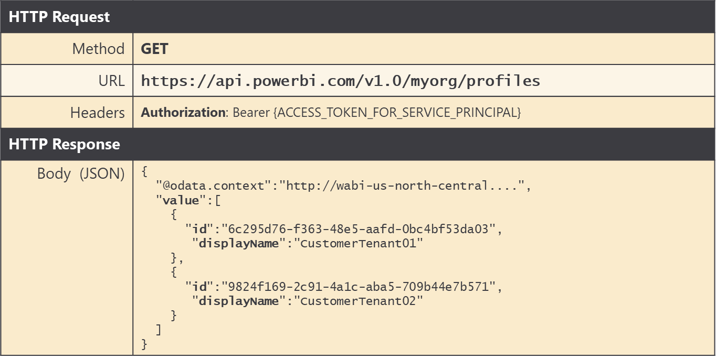

If you are programming with the Power BI .NET SDK, you can call **Profile.GetProfiles** using the following code.



Let's say you've just created a new service principal profile and you'd like to add it as a member of a workspace to give it access. You can execute an HTTP POST operation in which the request body provides the following JSON with an **identifier** property with the service principal object ID and an inner profile object with an id property that contains the profile Id.

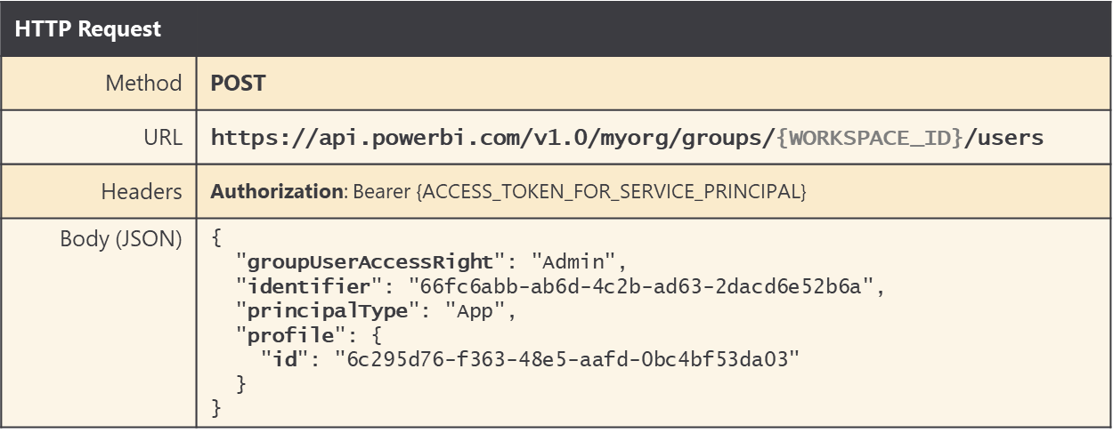

If you are programming with the Power BI .NET SDK, you can use the following code to add a service principal profile as a workspace member in the role of Admin.

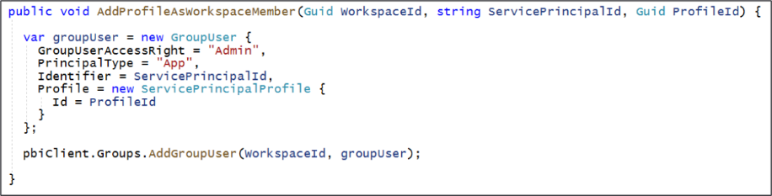

If you inspect the Access pane for a Power BI workspace in the Power BI Service, you can determine which accounts have been added as members. The following screenshot shows the Access pane for a workspace whose membership includes a user, a service principal and a service principal profile.

### Executing API Calls Under the Identity of a Service Principal Profile

There are two requirements for executing Power BI REST API calls under the identity of a service principal profile. First, you need to pass the access token for the parent service principal in the **Authorization** header. Second, you need to include a header named **X-PowerBI-profile-id** with the value for the service principal profile Id.

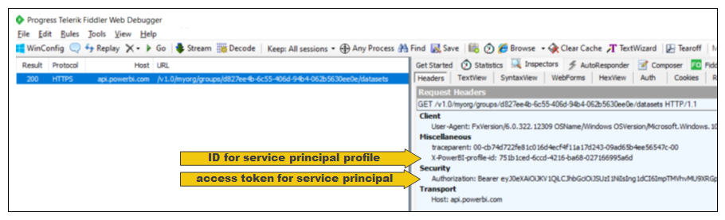

If you are using the Power BI .NET SDK, you can set the **X-PowerBI-profile-id** header value explicitly with the GUID for service principal profile Id using the following code.

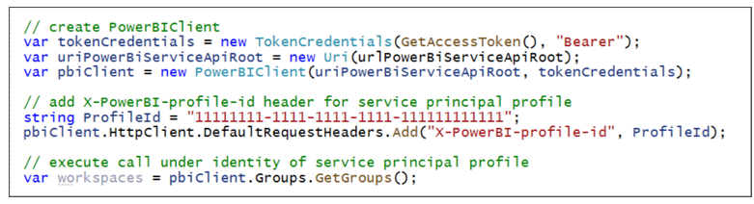

As you can see from the previous code listing, once you have added the **X-PowerBI-profile-id** header to the **PowerBIClient** object, you can just call Power BI REST API operations such as **Groups.GetGroups** as you normally would and the call will be executed under the identity of a service principal.

There is a second way to set the **X-PowerBI-profile-id** header for a **PowerBIClient** object. More specifically, you can initialize a **PowerBIClient** object by passing the GUID for a profile id in the constructor as shown in the following example.

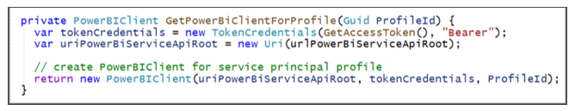

As you program a multitenant application, you need to switch back and forth between executing calls as the parent service principal and executing calls as a service principal profile. One strategy is to use a class-level property of type **PowerBIClient** named **pbiClient** and a method named **SetCallingContext** to switch between caller identities.

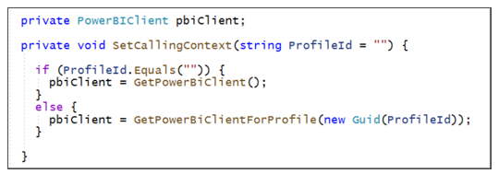

Now, let's say you need to create or manage a service principal profile. You can call **SetCallingContext** without passing a parameter so calls afterwards will execute under the identity of the service principal as shown in the following code.

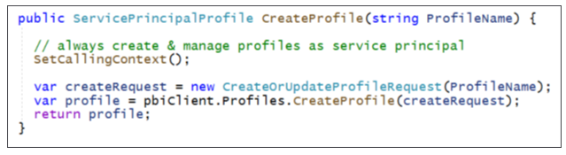

When you need to create and configure a new workspace for a new customer tenant, you want to execute that code as a service principal profile. Therefore, you should call **SetCallingContext** and pass the profile id so that Power BI REST operations called afterwards are executed as a service principal profile and not as the parent service principal.

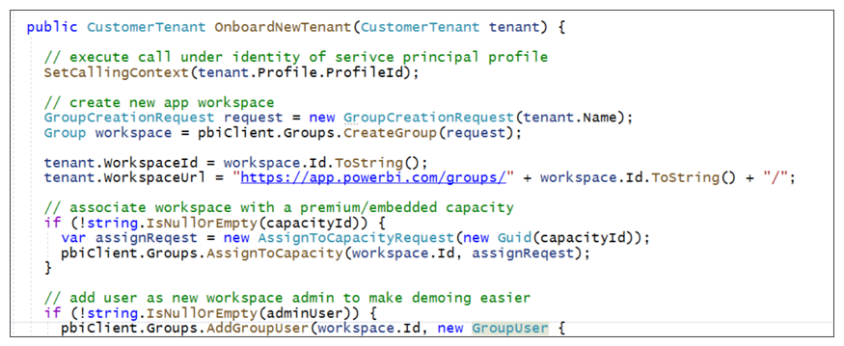

Once you have used a specific service principal profile to create and configure a workspace, you should use that same service principal profile later when you need to consume content from that workspace. The following code shows how to execute code as a service principal profile when retrieving embedding metadata and an embed token used to embed a report on a web page.

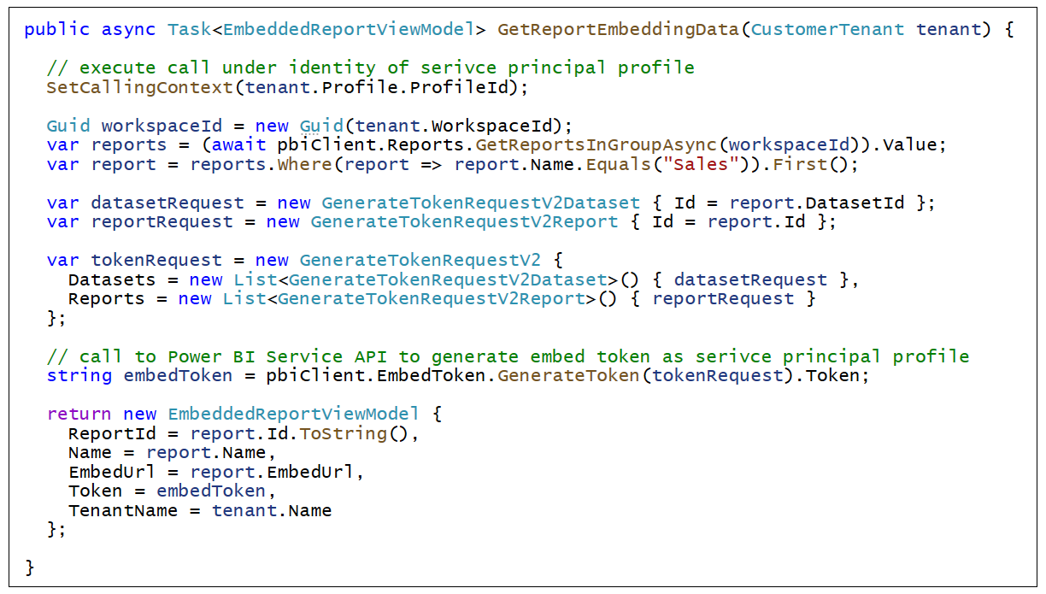

## Getting Started with the **AppOwnsDataMultiTenant** application

The **AppOwnsDataMultiTenant** application demonstrates how to manage a multitenant environment for Power BI embedding using service principal profiles. This sample application has been designed to use the best practice of creating a separate service principal profile for each new customer tenant.

The design strategy used by the **AppOwnsDataMultiTenant** application optimizes calls to the Power BI REST API while also providing complete dataset and datasource credential isolation at the customer tenant level. The design of the **AppOwnsDataMultiTenant** application makes it possible to scale upwards to manage an environment with up to and beyond 100,000 customer tenants.

The **AppOwnsDataMultiTenant** application provides a form which allows the user to create a new customer tenant. When using the application, you can enter the **Tenant Name** for a new customer and the details of the customer's database.

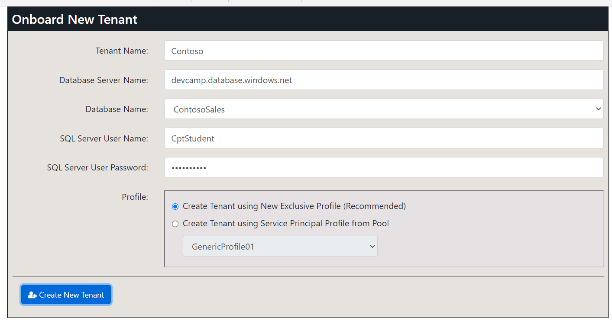

When you click the **Create New Tenant** button, the application responds by executing code which begins by creating a new service principal profile using the same name as the **Tenant Name**. After creating the service principal profile, the application then switches contexts and begins calling the Power BI REST API using that profile's identity to create a new workspace and populate it with content. This application design maintains a one-to-one relationship between service principal profiles and customer tenant workspaces which is what Microsoft recommends as a best practice.

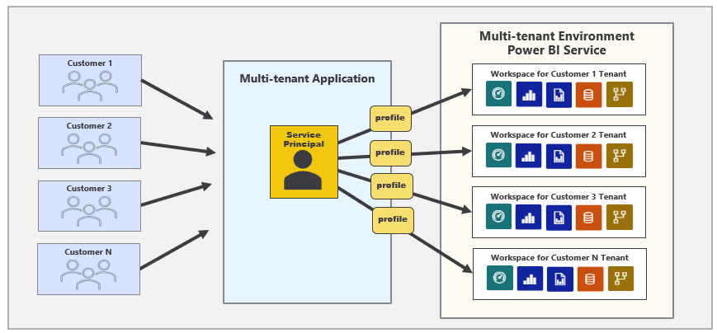

Keep in mind that **AppOwnsDataMultiTenant** is a proof-of-concept (POC) that doesn't include certain behavior that would be required in any real-world application. In particular, this application was not designed to authenticate or authorize the user. You can access all the pages of this application with anonymous access. If you are going to use the **AppOwnsDataMultiTenant** application as a starting point for something you are building, it will be your responsibility to add the code required to authenticate and authorize users who will be responsible for creating and managing customer tenants.

### Setting up your development environment

You can follow the steps in this section to set up the **AppOwnsDataMultiTenant** application for testing. To complete these steps, you will require a Microsoft 365 tenant in which you have permissions to create and manage Azure AD applications and security groups. You will also need Power BI Service administrator permissions to configure tenant-level settings for Power BI to give service principals to ability to access the Power BI Service API. If you do not have a Microsoft 365 environment for development and testing, you can create one with free trial licenses by following the steps in [Create a Development Environment for Power BI Embedding](https://github.com/PowerBiDevCamp/Camp-Sessions/raw/master/Create%20Power%20BI%20Development%20Environment.pdf).

To set up the **AppOwnsDataMultiTenant** application for testing, you will need to configure a Microsoft 365 environment with an Azure AD tenant by completing the following tasks.

* Create an Azure AD security group named **Power BI Apps**
* Configure Power BI tenant-level settings for service principal access
* Configure Power BI tenant-level settings to enable service principal profiles
* Create the Azure AD Application for the **AppOwnsDataMultiTenant** Application

The following sections will walk you through each of these setup tasks.

### Create an Azure AD security group named Power BI Apps

Begin by navigating to the [Groups management page](https://portal.azure.com/#blade/Microsoft_AAD_IAM/GroupsManagementMenuBlade/AllGroups) in the Azure portal. Once you get to the **Groups** page in the Azure portal, click the **New group** link.

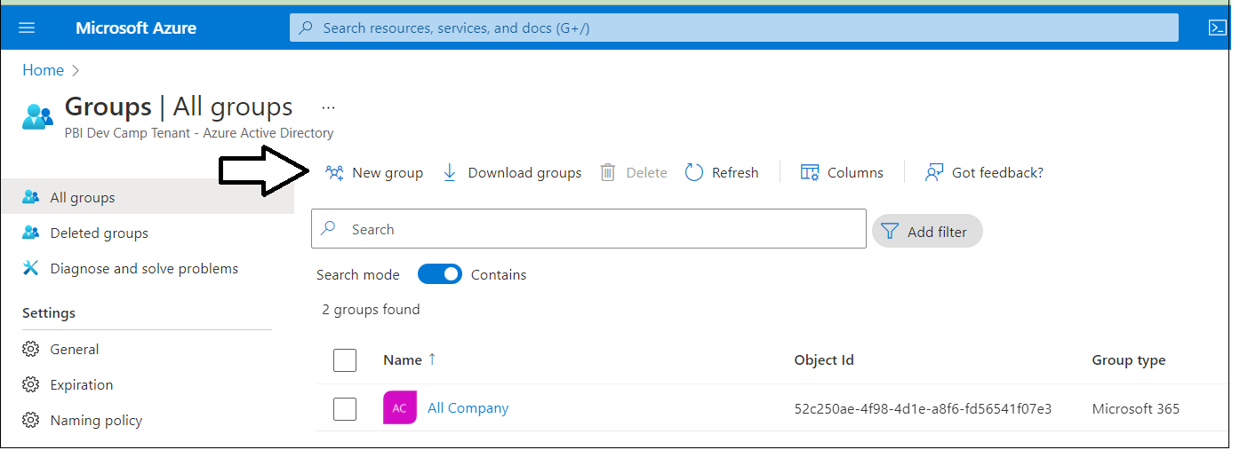

In the **New Group** dialog, Select a **Group type** of **Security** and enter a **Group name** of **Power BI Apps**. Click the **Create** button to create the new Azure AD security group.

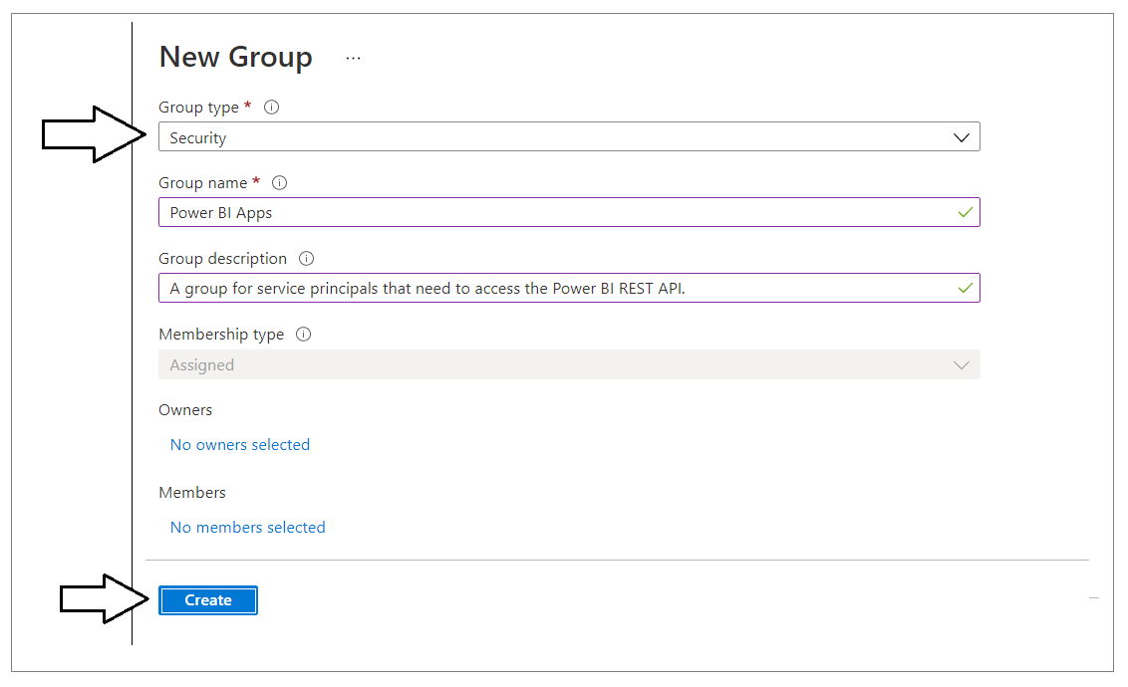

It might take a minute or two before the group appears. Refresh the **All Groups** page a few times until you can verify that you can see the new security group named **Power BI Apps** in the list of groups.

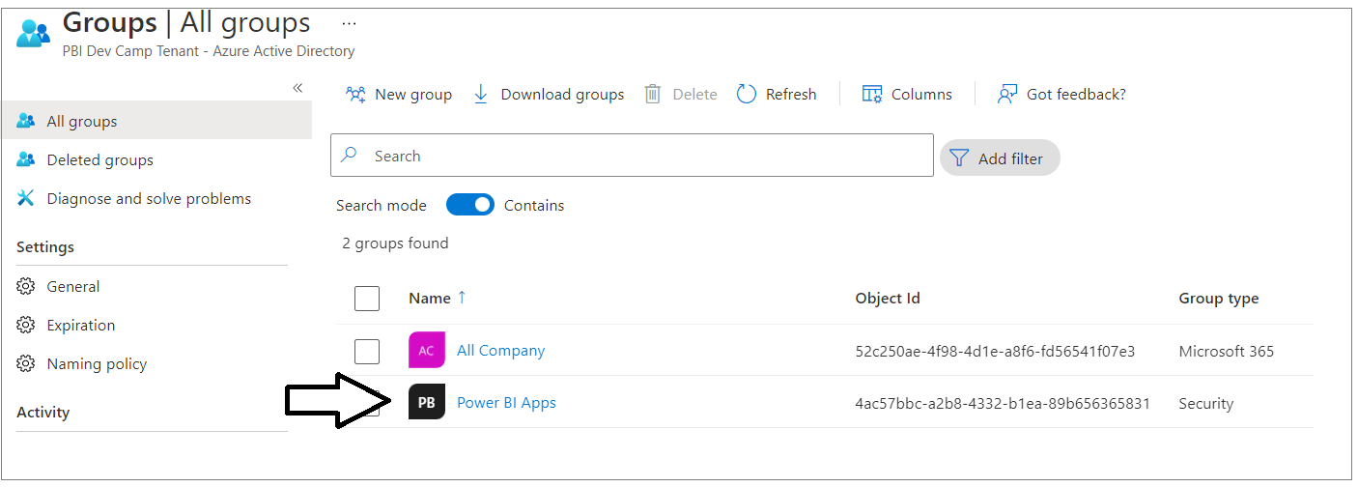

### Configure Power BI tenant-level settings for service principal profile access

Next, you need you enable a tenant-level setting for Power BI named **Allow service principals to use Power BI APIs**. Navigate to the Power BI Service admin portal at <https://app.powerbi.com/admin-portal>. In the Power BI Admin portal, click the **Tenant settings** link on the left.

](https://github.com/PowerBiDevCamp/TenantManagement/blob/main/Images/ReadMe/media/image4.png)

Move down in the **Developer settings** section and expand the **Allow service principals to use Power BI APIs** section.

](https://github.com/PowerBiDevCamp/TenantManagement/blob/main/Images/ReadMe/media/image5.png)

Note that the **Allow service principals to use Power BI APIs** setting is initially set to **Disabled**.

](https://github.com/PowerBiDevCamp/TenantManagement/blob/main/Images/ReadMe/media/image6.png)

Change the setting to **Enabled**. After that, set the **Apply to** setting to **Specific security groups** and add the **Power BI Apps** security group as shown in the screenshot below. Click the **Apply** button to save your configuration changes.

](https://github.com/PowerBiDevCamp/TenantManagement/blob/main/Images/ReadMe/media/image7.png)

You will see a notification indicating it might take up to 15 minutes to apply these changes to the organization.

](https://github.com/PowerBiDevCamp/TenantManagement/blob/main/Images/ReadMe/media/image8.png)

Now look down in the **Developer setting** section of the Power BI admin portal and locate and expand the section titled **Allow service principals to create and use profiles.**

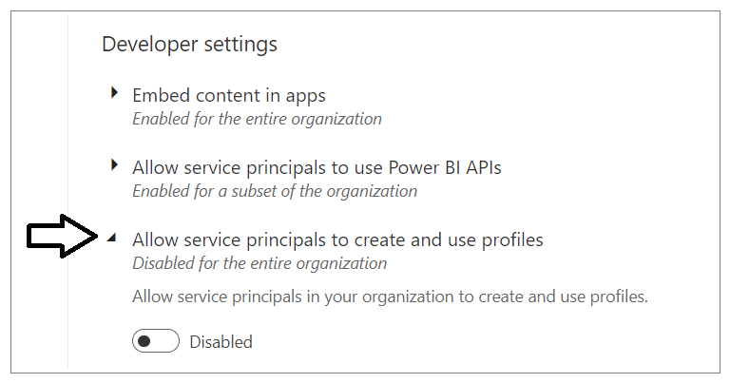

Change the setting to **Enabled**. After that, set the **Apply to** setting to **Specific security groups** and add the **Power BI Apps** security group as shown in the screenshot below. Click the **Apply** button to save your configuration changes.

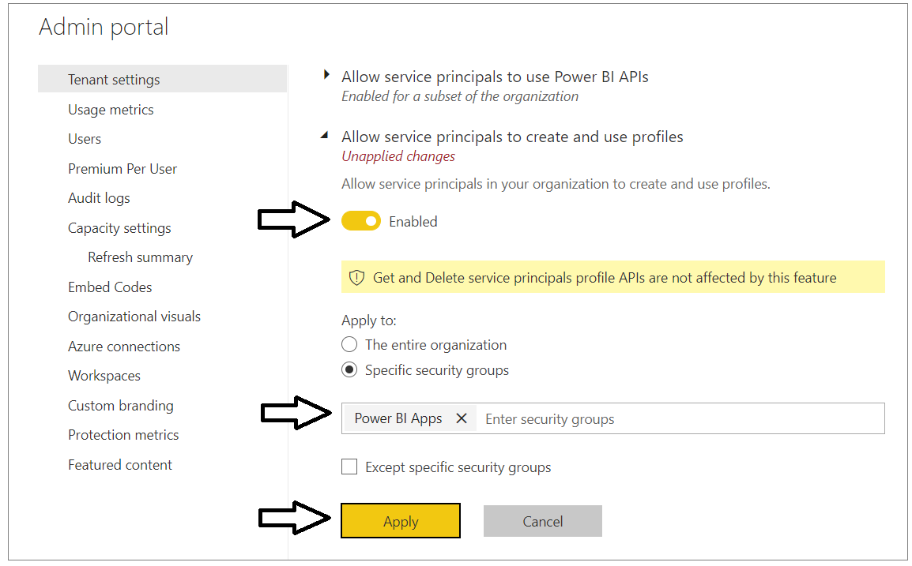

You will see another notification indicating it might take up to 15 minutes to apply these changes to the organization. Now scroll upward in the **Tenant setting** section of the Power BI admin portal and locate **Workspace settings**.

](https://github.com/PowerBiDevCamp/TenantManagement/blob/main/Images/ReadMe/media/image9.png)

Note that a Power BI tenant has an older policy by default where users require permissions to create Office 365 groups in order to create new Power BI workspaces. You must reconfigure this setting so that service principal profiles will be able to create new workspaces.

](https://github.com/PowerBiDevCamp/TenantManagement/blob/main/Images/ReadMe/media/image10.png)

In **Workspace settings**, set **Apply to : The entire organization** and click the **Apply** button to save your changes.

](https://github.com/PowerBiDevCamp/TenantManagement/blob/main/Images/ReadMe/media/image11.png)

You have now completed the configuration of Power BI tenant-level settings. Now you can move ahead to create the Azure AD application that will be used by the **AppOwnsDataMultiTenant** application.

Enable setting for map

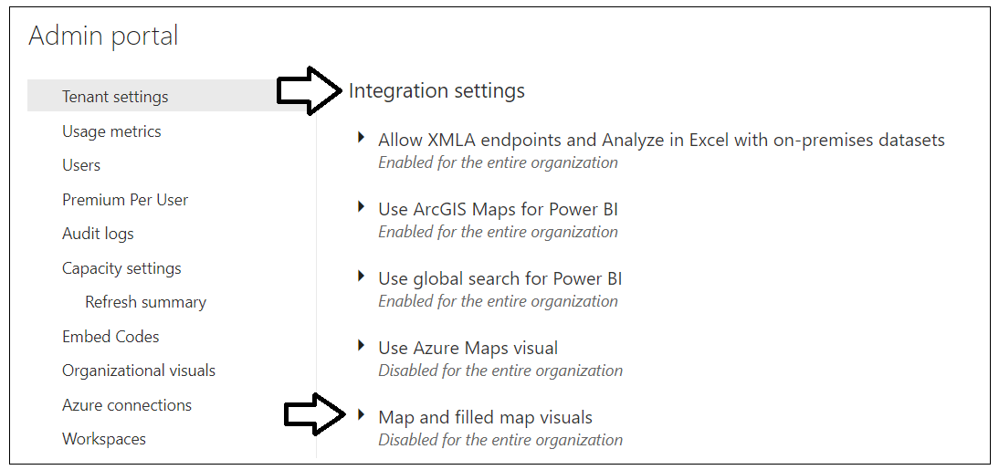

Zzzz

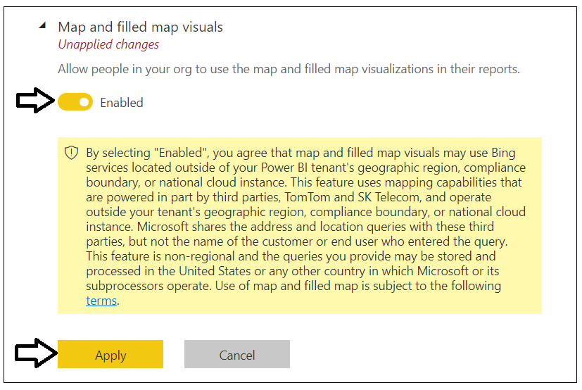

### Create the Azure AD Application for the ****AppOwnsDataMultiTenant**** Application

Login to the Azure portal to create the new Azure AD application. Begin by navigating to the [App registration](https://portal.azure.com/#blade/Microsoft_AAD_IAM/ActiveDirectoryMenuBlade/RegisteredApps) page in the Azure portal and click the **New registration** link.

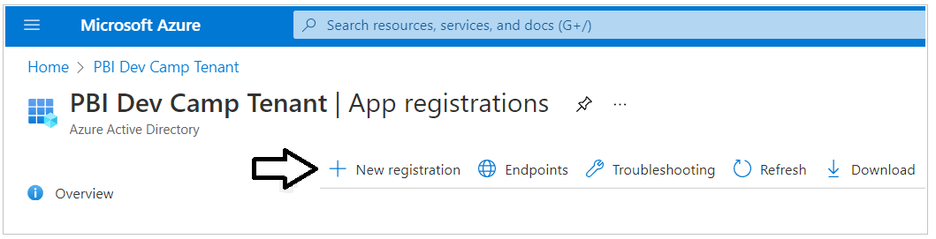

On the **Register an application** page, enter an application name such as **Power BI Embedding Tenant Manager** and accept the default selection for **Supported account types** of **Accounts in this organizational directory only**.

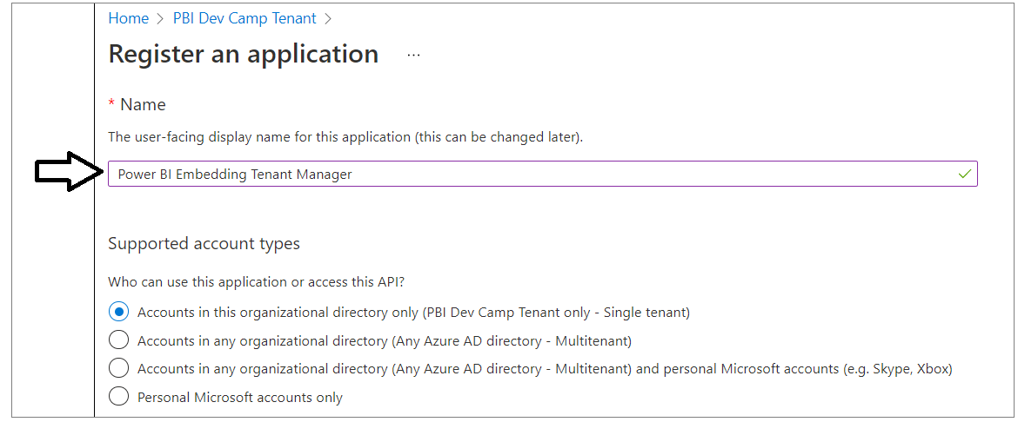

Complete the following steps in the **Redirect URI** section.

* Set the dropdown selection of **Web** in the dropdown box
* Do not enter a value for the **Redirect URI**. Leave it blank.
* Click the **Register** button to create the new Azure AD application.

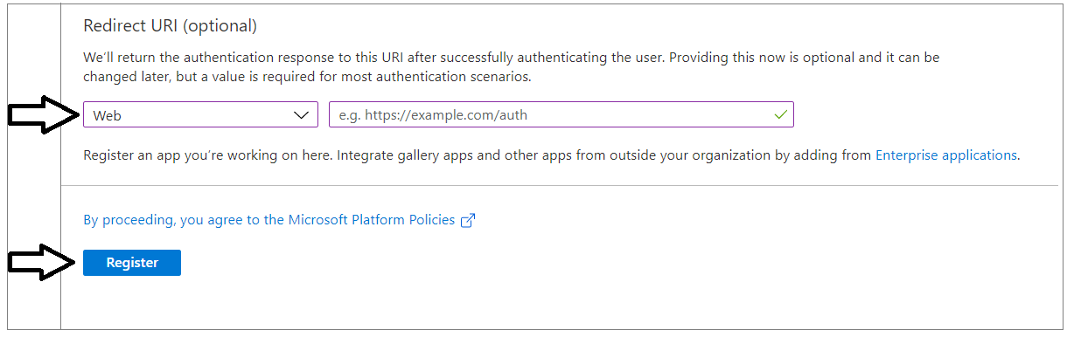

After creating a new Azure AD application in the Azure portal, you should see the Azure AD application overview page which displays the **Application ID**. Note that the ***Application ID*** is often called the ***Client ID***, so don't let this confuse you. You will need to copy this Application ID and store it so you can use it later to configure the project's support for Client Credentials Flow.

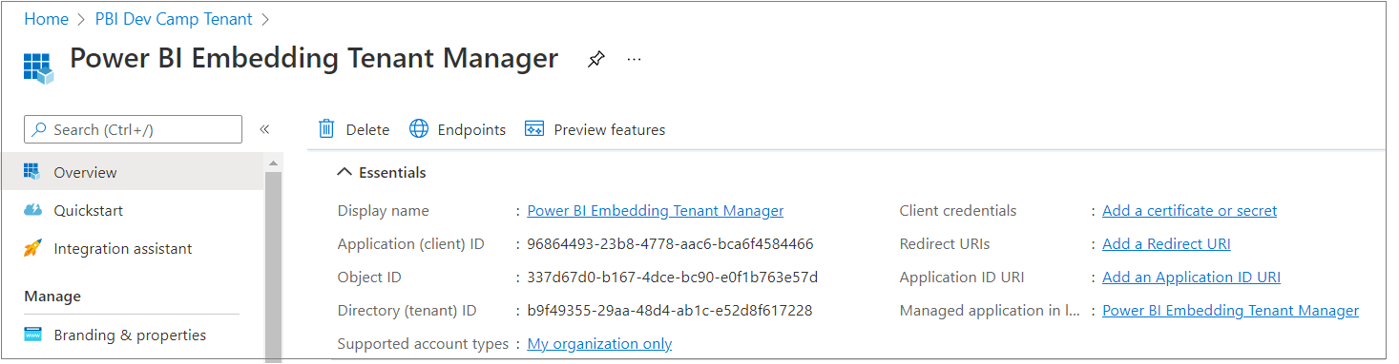

Copy the **Tenant ID** (aka Directory ID) and paste it into a text document so you can use it later in the setup process. Note that this **Tenant ID** value will be used by **AppOwnsDataMultiTenant** project to configure authentication with Azure AD.

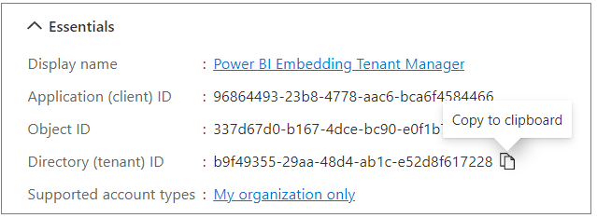

Next, repeat the same step by copying the **Client ID** and copying that into the text document as well.

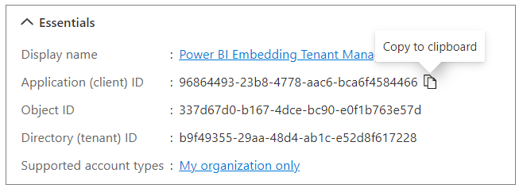

Your text document should now contain the **Tenant ID** and **Client ID**  as shown in the following screenshot.

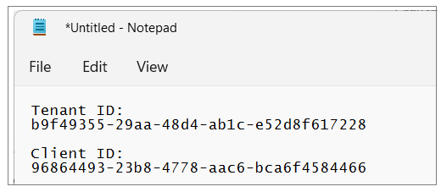

Next, you need to create a Client Secret for the application. Click on the **Certificates & secrets** link in the left navigation to move to the **Certificates & secrets** page. On the **Client secrets** tab, click the **New client secret** button as shown in the following screenshot.

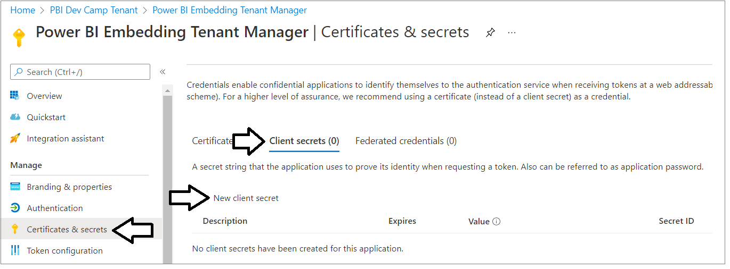

In the **Add a client secret** dialog, add a text description such as **Test Secret** and then click the **Add** button to create the new Client Secret.

](https://github.com/PowerBiDevCamp/TenantManagement/blob/main/Images/ReadMe/media/image20.png)

Once you have created the Client Secret, you should be able to see its **Value** in the **Client secrets** section. Click on the **Copy to clipboard** button to copy the Client Secret into the clipboard.

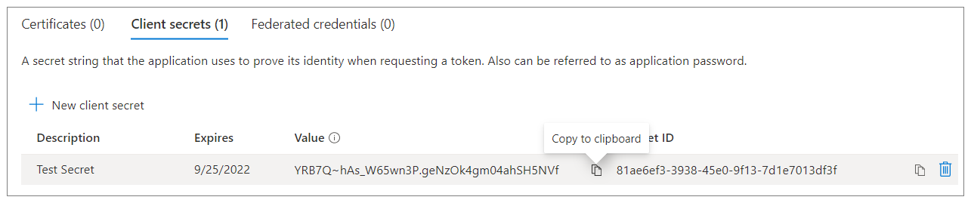

Paste the **Client Secret** into the same text document with the **Client ID** and **Tenant ID**.

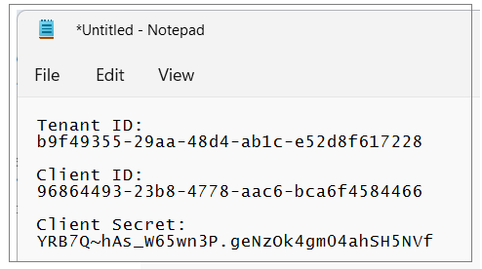

At this point, you have the Tenant Id, Client Id and Client Secret. This is all you need to authenticate with Azure AD to acquire an access token for the service principal. However, you need to capture one more GUID for the service principal object Id. You will need this Id value if you need to add the service principal as a member in a Power BI workspace.

Navigate back to the Overview page for the new Azure AD application. Now click on the link so see details on the Managed application in local tenant as shown in the following screenshot to navigate to the application's **Properties** page.

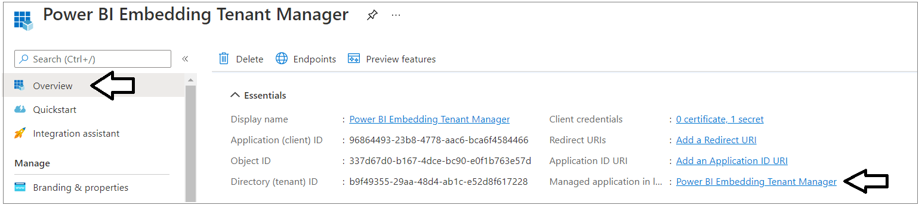

On the **Properties** page, locate the **Object ID** value and copy it to the clipboard. This value represents the service principal object Id.

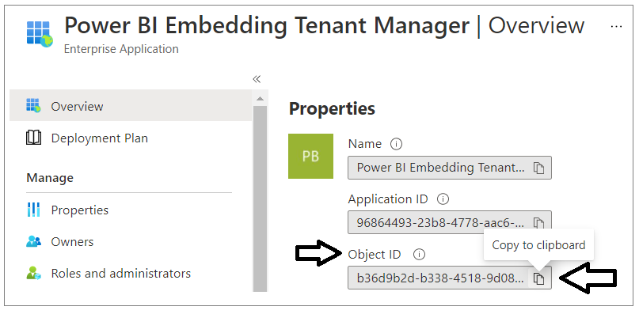

Now paste the service principal into the text document with the other values as shown in the following screenshot.

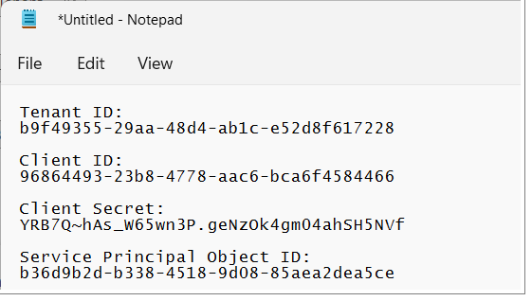

Save the text file so you don’t accidently close it and lose the configuration data inside. You will copy and paste these Id values into the **AppOwnsDataMultiTenant** project in the next section.

### Add the Azure AD Application to the Power BI Apps Group

In this step you will finalize the configuration in Azure AD by adding the **Power BI Embedding Tenant Manager** application to the **Power BI Apps** security group. Navigate back to the [Groups management page](https://portal.azure.com/#blade/Microsoft_AAD_IAM/GroupsManagementMenuBlade/AllGroups)  and locate the security group created earlier named **Power BI Apps**. Click on the **Power BI Apps** link to drill into the summary page for this security group.

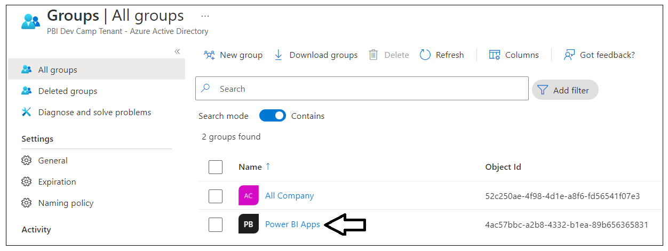

On the **Power BI Apps** summary page, click the **Members** link to drill navigate to the **Members** page.

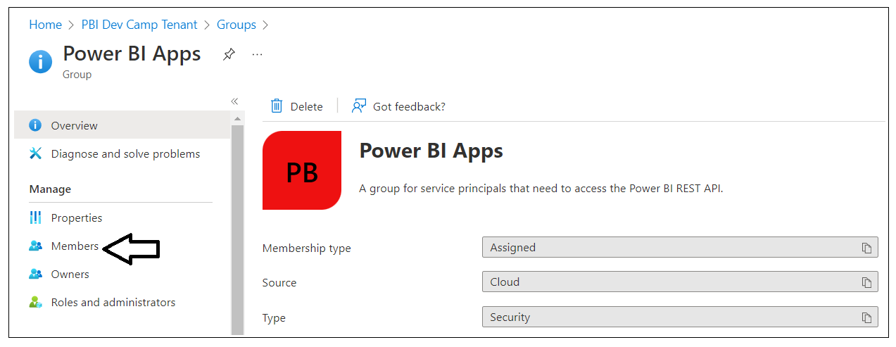

On the **Members** page, click the **Add members** link to display the **Add members** pane.

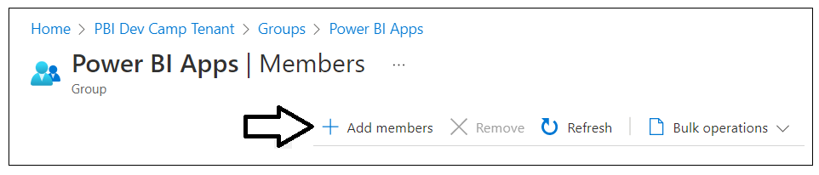

In the **Add members** pane, locate and select the **Power BI Embedding Tenant Manager** application. Add this application to the **Power BI Apps** security group.

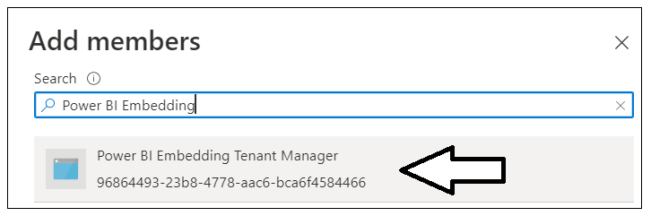

Verify that the **Power BI Embedding Tenant Manager** application is now a member of the **Power BI Apps** group.

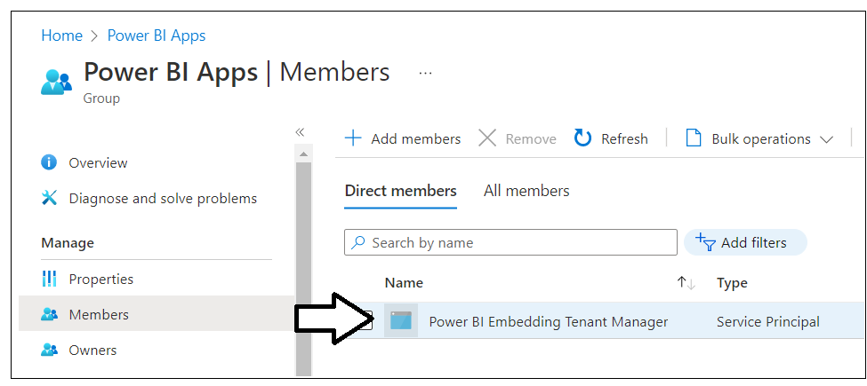

You are now finished in configuring Azure AD for the application setup.

## Set Up the AppOwnsDataMultiTenant Application in Visual Studio 2022

In order to run and test the **AppOwnsDataMultiTenant** project on a developer workstation, you must install the .NET 6 SDK and/or Visual Studio 2022. If you use Visual Studio 2022, you can use any edition including the free Community edition. While this document will walk through the steps of opening and running the **this** project using Visual Studio 2022, you can also open and run the project using Visual Studio Code if you prefer that IDE.

Here are links to download this software if you need them.

* .NET 6 SDK – [[**download**](https://dotnet.microsoft.com/en-us/download/dotnet/6.0)]
* Visual Studio 2022 – [[**download**](https://visualstudio.microsoft.com/downloads/)]
* Visual Studio Code – [[**download**](https://code.visualstudio.com/download)]

### Download the Source Code

The source code for **AppOwnsDataMultiTenant** is maintained in a GitHub repository at the following URL.

[**https://github.com/PowerBiDevCamp/AppOwnsDataMultiTenant**](https://github.com/PowerBiDevCamp/TenantManagement)

You can download the **AppOwnsDataMultiTenant** project source files in a single ZIP archive using [this link](https://github.com/PowerBiDevCamp/AppOwnsDataMultiTenant/archive/refs/heads/main.zip). If you are familiar with the **git** utility, you can clone the project source files to your local developer workstation using the following **git** command.

git clone https://github.com/PowerBiDevCamp/AppOwnsDataMultiTenant.git

Once you have downloaded the source files for the **AppOwnsDataMultiTenant** repository to your developer workstation, you will see there is a top-level project folder named **AppOwnsDataMultiTenant** which contains several files including a solution file named **AppOwnsDataMultiTenant.sln** and a project file named **AppOwnsDataMultiTenant.csproj**.

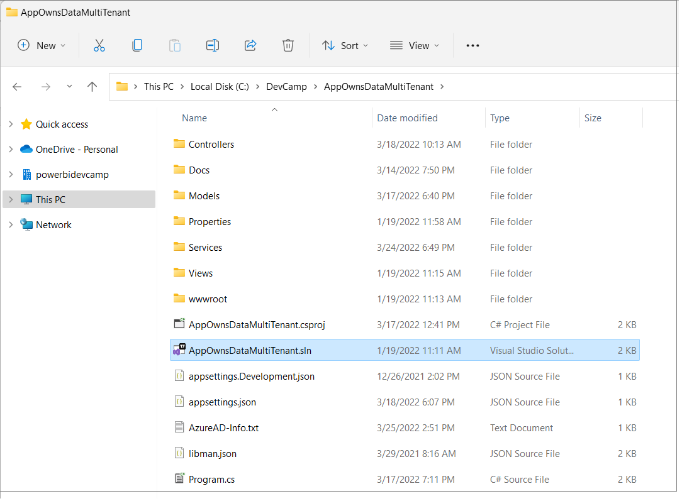

### Open the Project in Visual Studio 2022

Launch Visual Studio 2022 and use the **File > Open > Project/Solution** menu command to open the solution file named **AppOwnsDataMultiTenant.sln**. You should note that this development project has been built as a .NET 6 MVC Web Application as shown in the following screenshot.

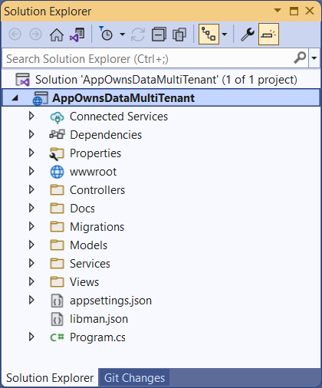

Let's quickly review the NuGet packages that have been installed in the **AppOwnsDataMultiTenant** project. There are several NuGet packages which add Entity Framework support which make it possible to quickly create the SQL Server database associated with this project. There is a package included to add Azure AD authentication support named **Microsoft.Identity.Web**. The package named **Microsoft.PowerBI.Api** is the Power BI .NET SDK which has been included to support .NET programming with the Power BI REST API.

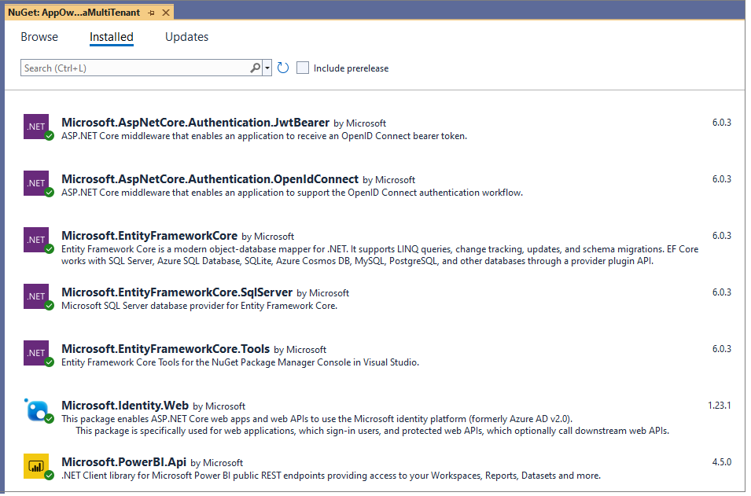

### Update application settings in the appsettings.json file

Before you can run the application in the Visual Studio debugger, you must update several critical application settings in the **appsettings.json** file. Open the **appsettings.json** file and examine the JSON content inside. There are three important sections named **AzureAd**, **AppOwnsDataMultiTenantDB** and **DemoSettings**.

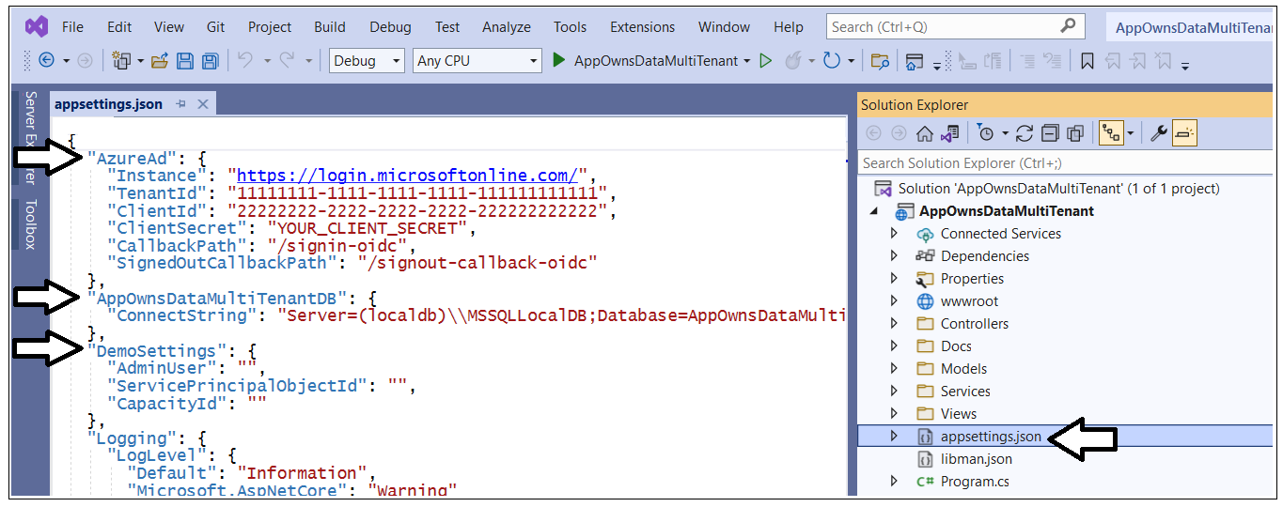

Inside the **AzureAd** section, update the **TenantId**, **ClientId** and **ClientSecret** with the data you collected when creating the Azure AD application named **Power BI Tenant Management Application.**

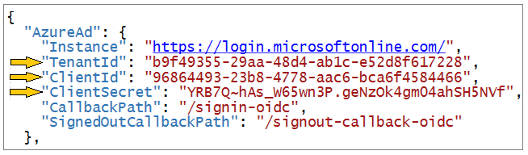

Now let's examine the **AppOwnsDataMultiTenantDB** section and the setting inside named **ConnectString**. This is the connection string that will be used by the Entity Framework to create the SQL Server database that will be used by the **AppOwnsDataMultiTenant** application. If you are using Visual Studio 2022, you should be able leave the database connection string the way it is with the **Server** setting of **(localdb)\\MSSQLLocalDB**. If you'd rather create the **AppOwnsDataMultiTenantDB** database in a different location, you can update the value of this connection string to point to a different server.



In the **DemoSettings** section there is a property named **AdminUser**. The reason that this property exists has to with you being able to view and examine Power BI workspaces as they are created by service principal profiles. There is code in the **AppOwnsDataMultiTenant** application that will add the user specified by the **AdminUser** setting as a workspace admin any times it creates a new Power BI workspace. This just makes things much easier for you to see what's going on when you begin to run and test the application.

Update the **AdminUser** setting with your Azure AD account name so that you will be able to see all the Power BI workspaces created by this application.

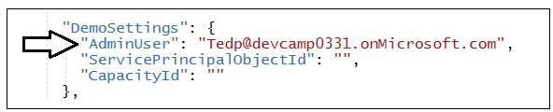

In the **DemoSettings** section there is a property named **ServicePrincipalObjectId**. The reason this property exists has to do with adding the service principal or a service principal profile as a workspace member. Update the **ServicePrincipalObjectId** setting with the value you Service Principal Object Id value you collected earlier.

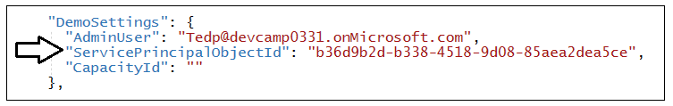

In the **DemoSettings** section there is a property named **CapacityId**. The reason this property exists has to do with automating the step of associating new workspaces with a premium capacity. If you have the GUID-based ID for a premium capacity you can update this setting and the application will automatically associate new workspaces with this capacity each time it creates a new workspace. If you don't have a Capacity ID, that is not a problem. Simply leave the **CapacityId** setting as an empty string and the application will ignore this setting.

Once you have made your changes. save and close the **appsettings.json** file. You are now ready to move on to the step where you will create the new database named **AppOwnsDataMultiTenantDB**.

### Create the AppOwnsDataMultiTenantDB database

When developing with service principal profiles, it's a common practice to use a custom database to track service principal profiles and customer tenants. The **AppOwnsDataMultiTenant** application has been designed with a SQL Server database named **AppOwnsDataMultiTenantDB** which will provide two tables named **Profiles** and **Tenants** to track service principal profiles and customer tenants as they are created by the application.

Before you can run the application in Visual Studio, you must create the **AppOwnsDataMultiTenantDB** database. This database schema has been created using the .NET 6 version of the Entity Framework. In this step, you will execute two PowerShell cmdlets provided by Entity Framework to create the database.

Before creating the **AppOwnsDataMultiTenantDB** database, take a moment to understand how it’s been structured. Start by opening the file named **AppOwnsDataMultiTenantDB.cs** in the **Models** folder. Note that you shouldn't make any changes to **AppOwnsDataMultiTenantDB.cs**. You are just going to inspect the file to understand how the **AppOwnsDataMultiTenantDB** database is structured.

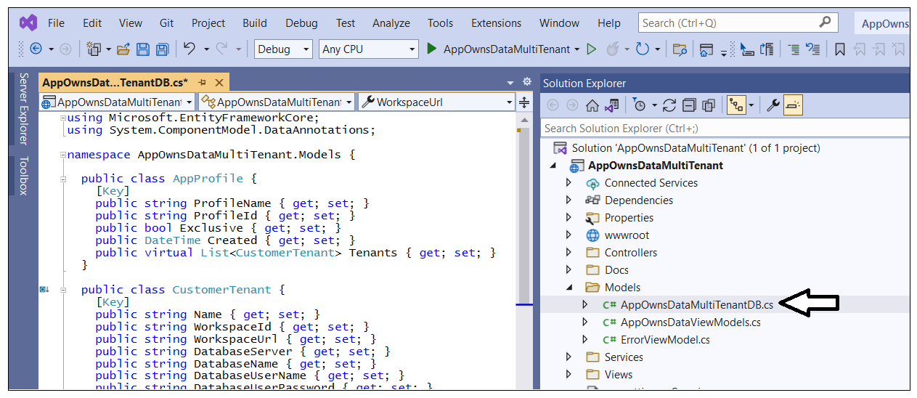

When you inspect the code inside **AppOwnsDataMultiTenantDB.cs**, you will see a class named **AppOwnsDataMultiTenantDB** that derives from **DbContext**. This class adds support for automatic database generation using Entity Framework. The **AppOwnsDataMultiTenantDB** class serves as the top-level class for the Entity Framework which contains two **DBSet** properties named **Profiles** and **Tenants**.

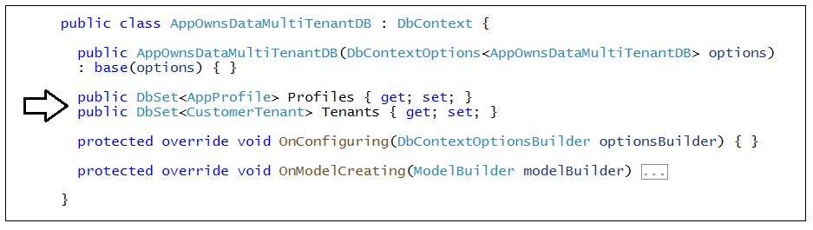

When you generate the database, each of these **DBSet** properties will be created as database tables. The **Profiles** table is generated using the table schema defined by the **AppProfile** class.

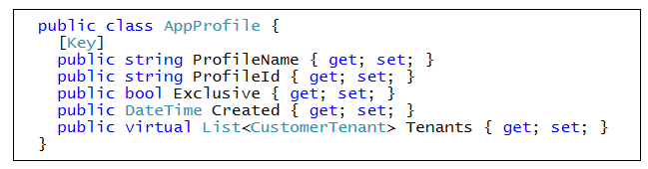

As you saw earlier, Power BI tracks an **id** and **displayName** property for each profile. The **AppProfile** class defines **ProfileName** and **ProfileId** to track these properties. However, the **AppProfile** class defines two extra properties named **Exclusive** and **Created** so that application can track addition metadata about each service principal profile it creates.

The **Tenants** table is generated using the table schema defined by the **CustomerTenant** class.

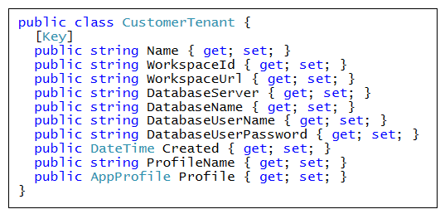

After you have inspected the code used to generated the database, close the source file named **AppOwnsDataMultiTenantDB.cs** without saving any changes. The next step is to run the PowerShell commands to create the project database named **AppOwnsDataMultiTenantDB**.

Open the Package Manager console using **Tools > NuGet Package Manager > Package Manager Console**.

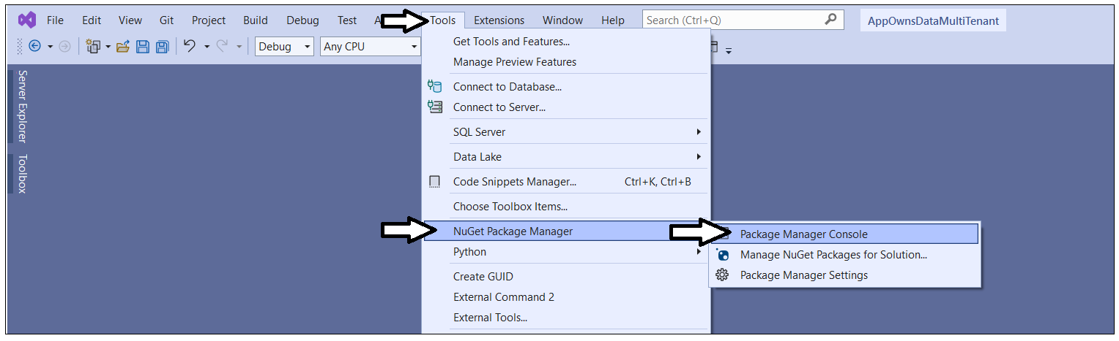

You should see the **Package Manager Console** command prompt where you can execute PowerShell commands.

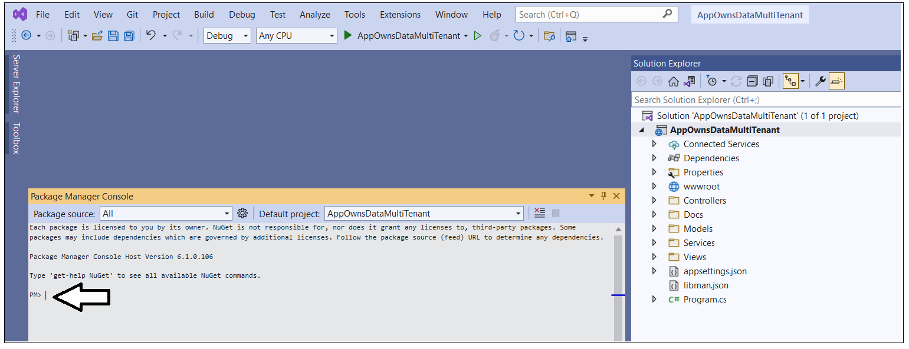

Type and execute the following **Add-Migration** command to create a new Entity Framework migration in the project.

Add-Migration InitialCreate

The **Add-Migration** command should run without errors. If this command fails you might have to modify the database connection string in **appsettings.json**.

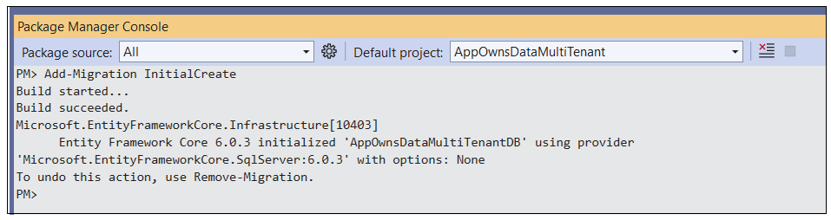

After running the **Add-Migration** command, you will see a new folder has been added to the project named **Migrations** with several C# source files. There is no need to change anything in these source files but you can inspect what's inside them if you are curious how the Entity Framework does its work.

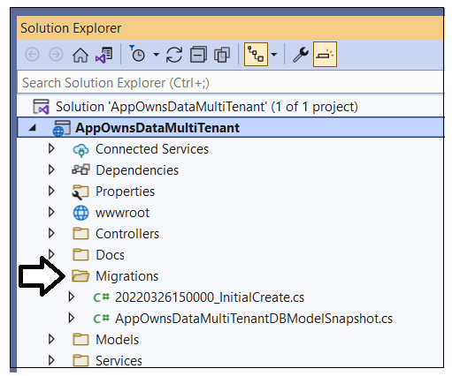

Return to the **Package Manager Console** and run the following **Update-Database** command to generate the database named **AppOwnsDataMultiTenantDB**.

Update-Database

The **Update-Database** command should run and generate the database named **AppOwnsDataMultiTenantDB**.

](https://github.com/PowerBiDevCamp/TenantManagement/blob/main/Images/ReadMe/media/image38.png)

In Visual Studio, you can use the **SQL Server Object Explorer** to see the database that has just been created. Open the **SQL Server Object Explorer** by invoking the **View >** **SQL Server Object Explorer** menu command.

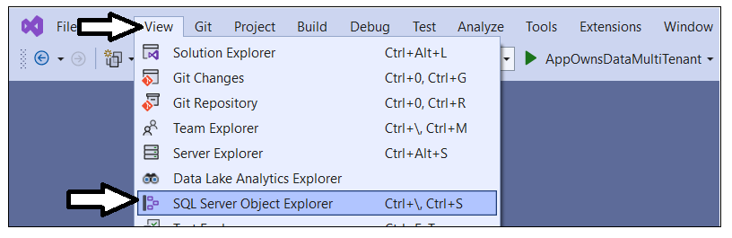

Expand the **Databases** node for the server you are using and verify you an see the new database named **AppOwnsDataMultiTenantDB**.

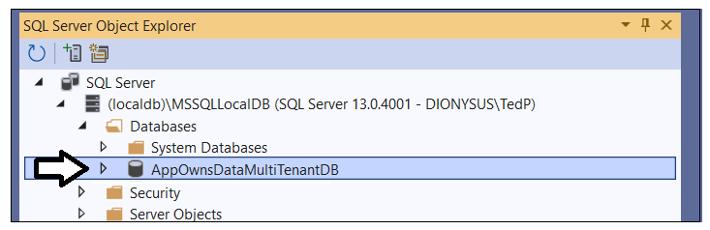

If you expand the **Tables** node for **AppOwnsDataMultiTenantDB**, you should see the two tables named **Profiles** and **Tenants**.

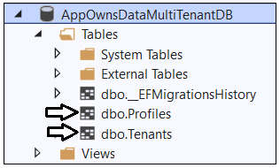

The **AppOwnsDataMultiTenantDB** database has now been set up and you are ready to run the application in the Visual Studio debugger.

## Test the AppOwnsDataMultiTenant Application

Launch the **AppOwnsDataMultiTenant**  application in the Visual Studio debugger by pressing the **{F5}** key or clicking the Visual Studio **Play** button with the green arrow and the caption **IIS Express**.

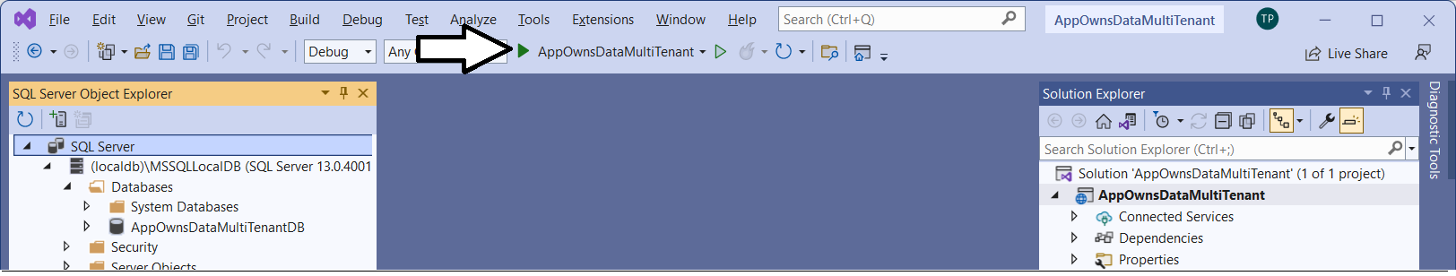

When the application starts, you should see its welcome page as shown in the following screenshot.

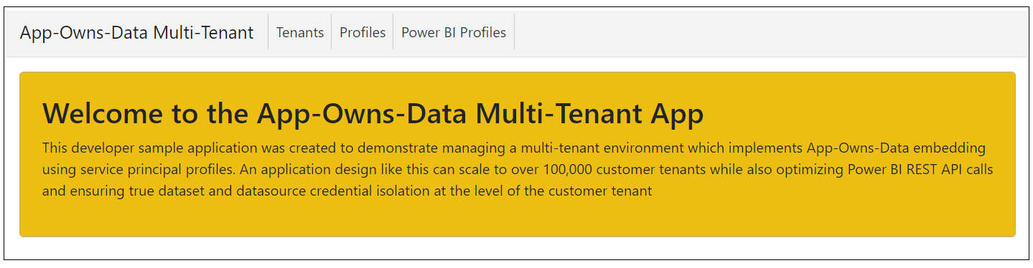

Now that the application is up and running, it's time to create the first customer tenant.

### Create New Customer Tenants

Navigate to the **Tenants** page.

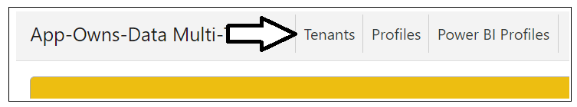

Click the **Onboard New Tenant** button to display the **Onboard New Tenant** page.

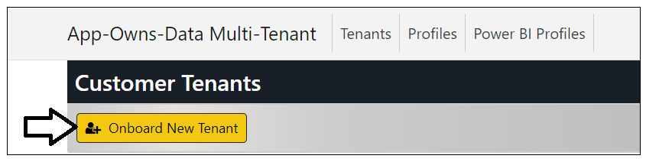

On the **Onboard New Tenant** page, enter a **Tenant Name** of **Wingtip**. Leave all the other input elements with their default values. Click to **Create New Tenant** button to begin the process of creating a new customer tenant.

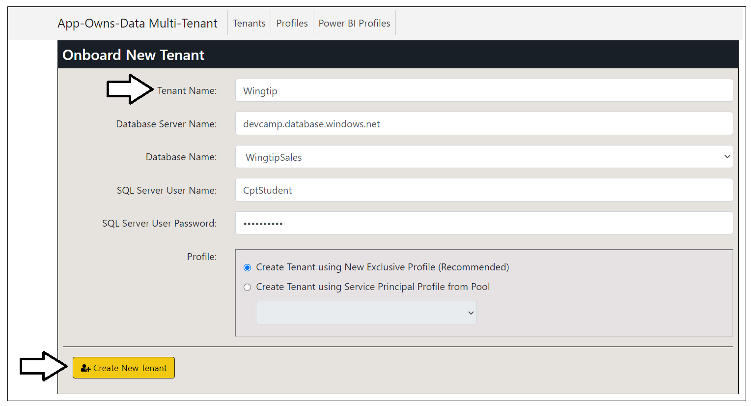

What happens when you click the **Create New Tenant** button? The **AppOwnsDataMultiTenant** application uses the Power BI REST API to create a service principal profile using same name as Tenant Name. After the service principal profile is created, the application then switches contexts and executes the following API calls under the identity of the new service principal profile.

* Create a new Power BI workspace
* Upload a [template PBIX file](https://github.com/PowerBiDevCamp/AppOwnsDataMultiTenant/raw/main/wwwroot/PBIX/DatasetTemplate.pbix) to create the Sales dataset and the Sales report
* Update dataset parameters on Sales dataset to point to this customer's database
* Patch credentials for the SQL datasource used by the Sales dataset
* Start a refresh operation on the Sales database

While this work is going on, the application's user is shown an animated image.

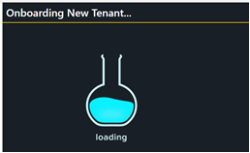

After a few seconds, you should see the new customer tenant has been created.

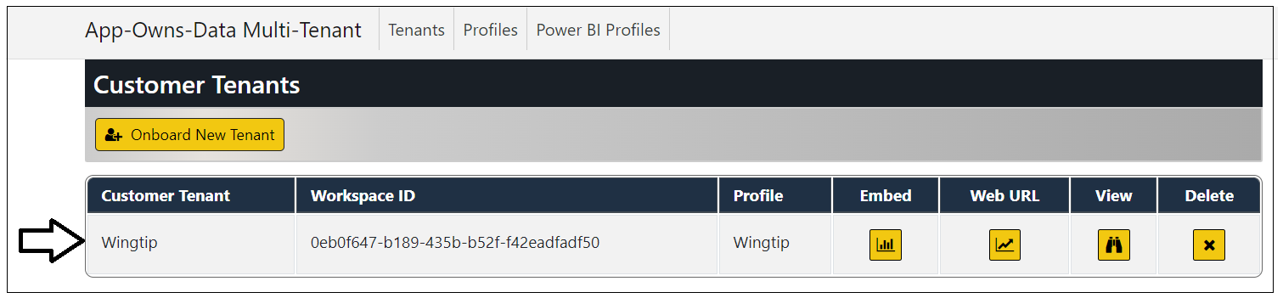

Click the **Onboard New Tenant** button again to create a second tenant. This time, set **Tenant Name** to **Contoso** and select **ContosoSales** from the dropdown list for **Database Name**. After that, click **Create New Tenant**.

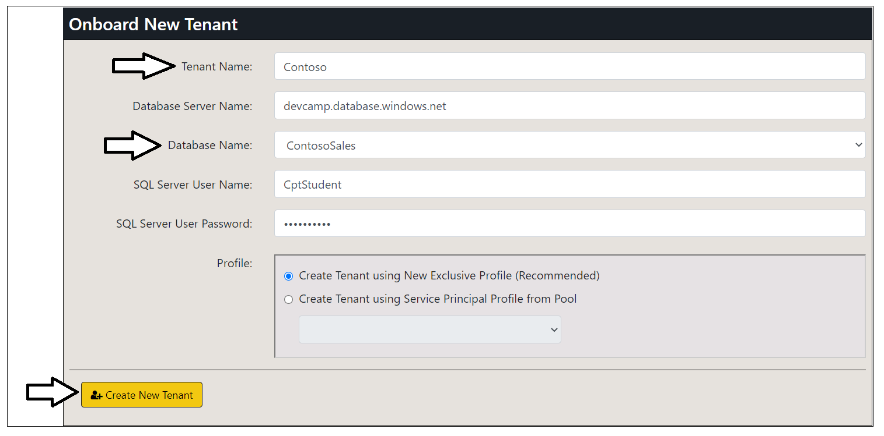

You should now have two customer tenants. Note they each tenant has a different **Profile**.

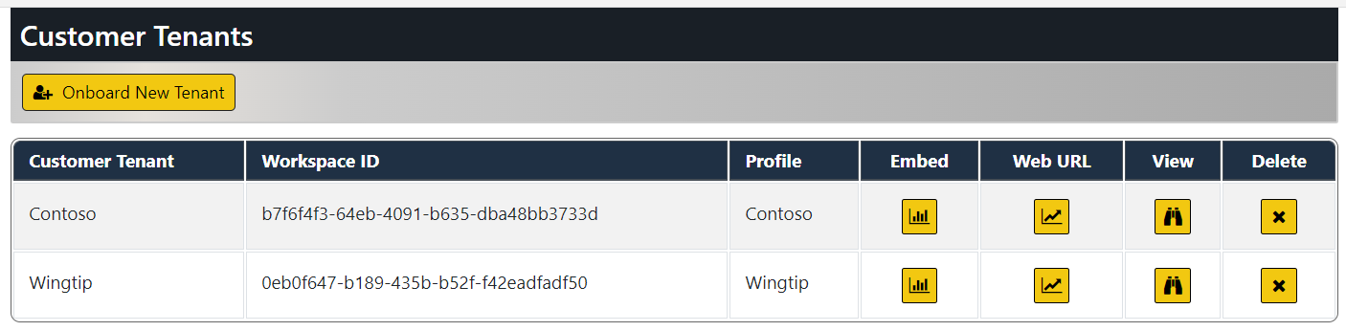

Now let's discuss what's going on behind the scenes.

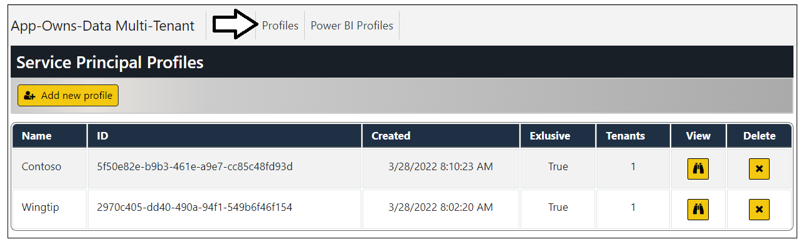

The **AppOwnsDataMultiTenant** application also create a new record in the **Tenants** table of the **AppOwnsDataMultiTenantDB** database. Note that the profile associated with this customer tenant is tracked in the **ProfileName** column.



Xxxxx

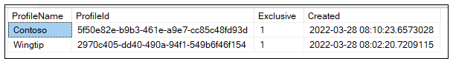

xxxx

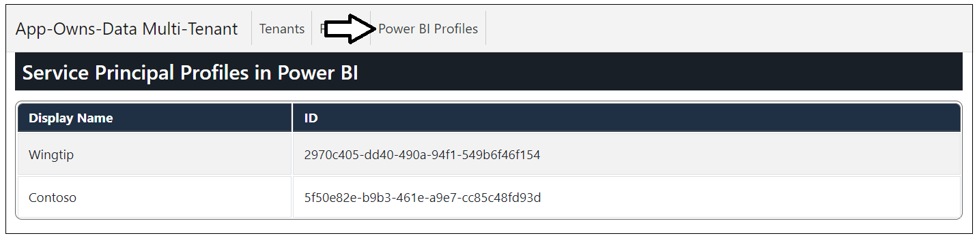

Xxxx

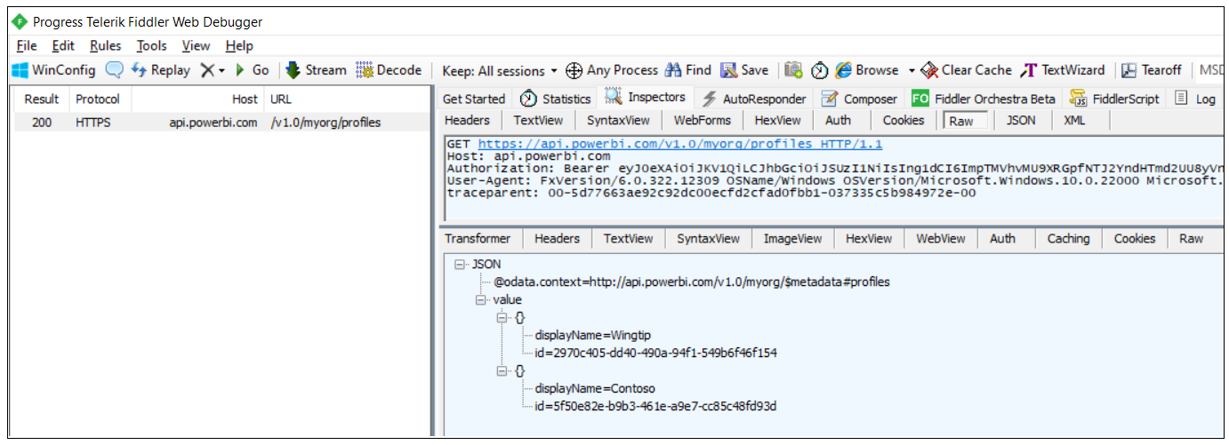

xxx

Navigate back to the Tenants page



Click on the **View** button for a specific tenant on the **Power BI Tenants** page to drill into the **Tenant Details** page.

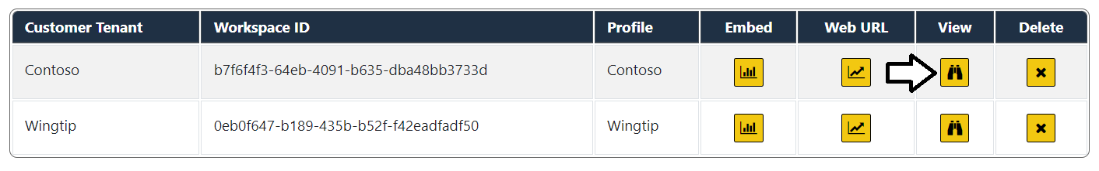

The **Tenant Details** page displays Power BI workspace details including its members, datasets and reports.

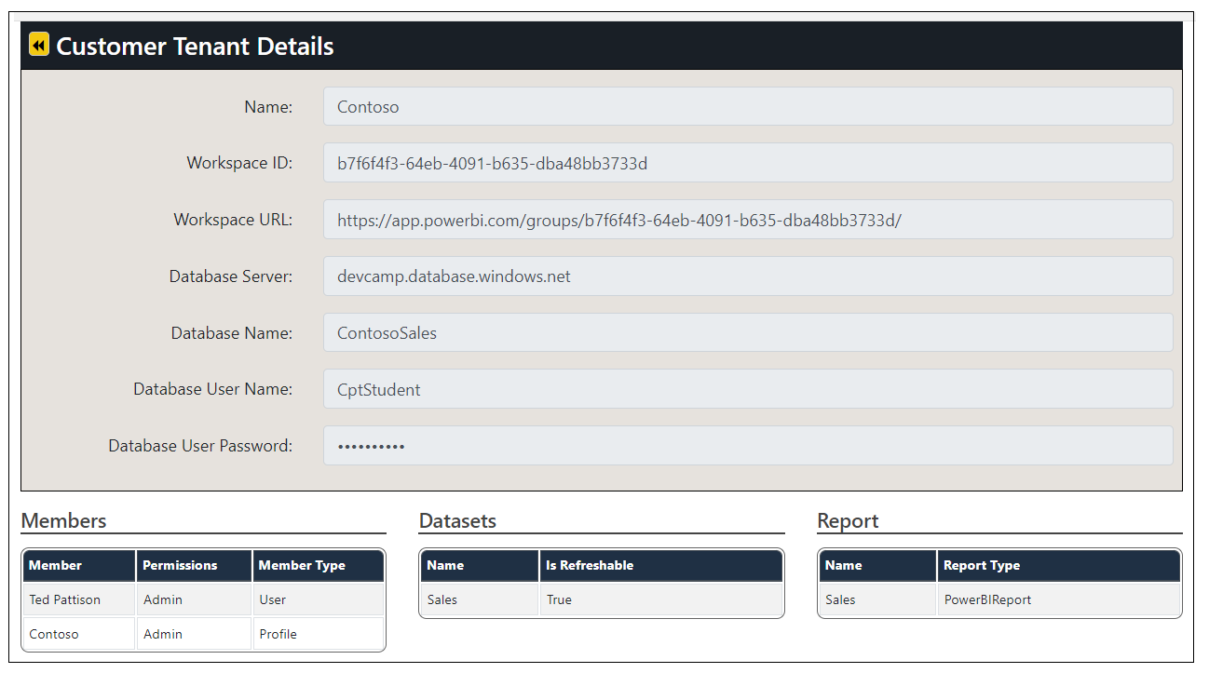

Sss

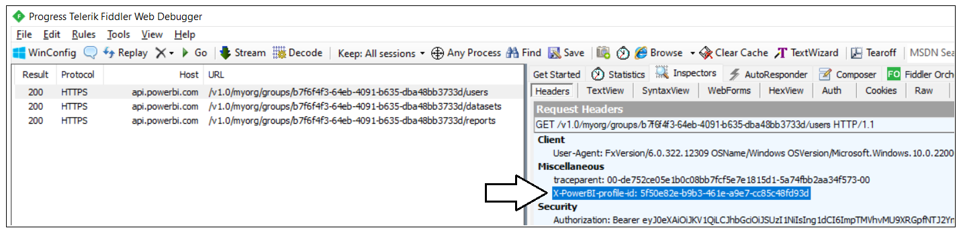

Click on the back arrow to return to the **Power BI Tenants** page.

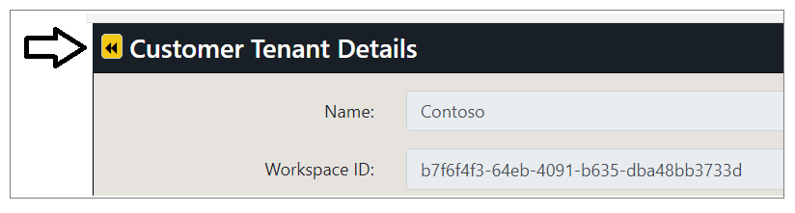

If you're interested, you can examine the details of other tenants as well.

### Embed Reports

Now it's time to make use of the **AppOwnsDataMultiTenant** application's ability to embed reports. When navigate to the **Embed** page for a customer tenant, the **AppOwnsDataMultiTenant** application must acquire an access token for whichever app identity was used to create the customer tenant. The service principal that is configured as the **Owner** of a tenant will be the only service principal who will have access to access the target workspace in Power BI.

Move to the **Power BI Tenants** page and click on the **Embed** button for the first customer tenant.

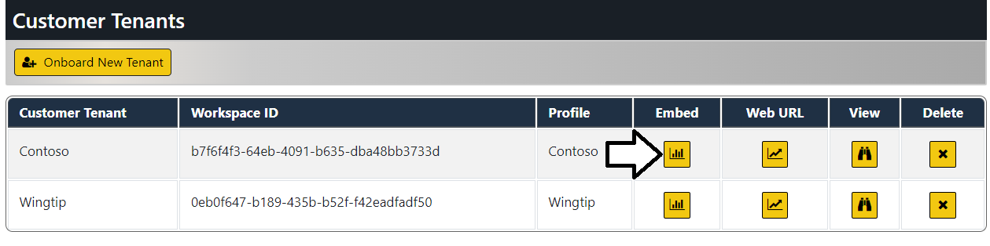

You should now see a page with an embedded report for that tenant. When you click the **Embed** button to embed a report for a customer tenant, the **TenanantManagement** application retrieves credentials for the app identity associated with the tenant from the **AppOwnsDataMultiTenantDB** database. It then uses those credentials to acquire an access token from Azure AD using Client Credentials Flow. That access token is then used to communicate with the Power BI Service to retrieve report metadata and generate an embed token for the embedding process.

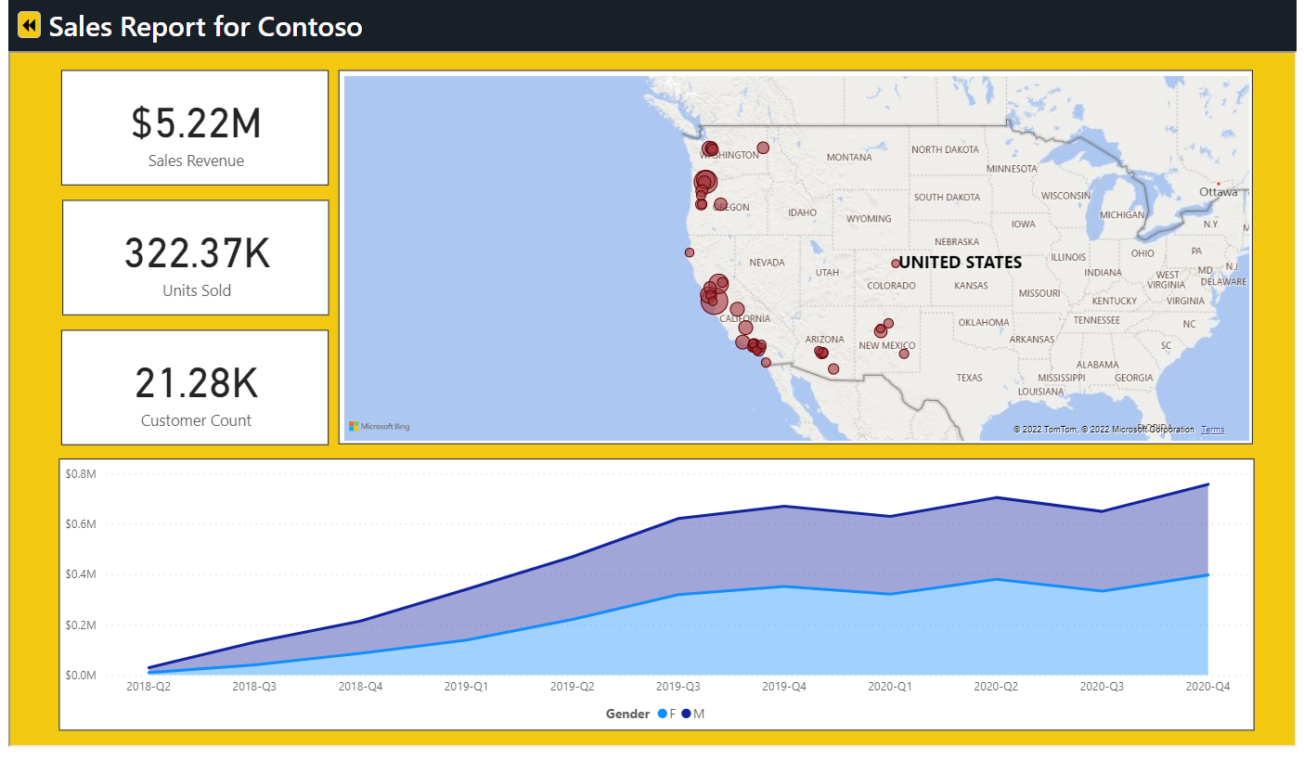

Click on the back arrow button to return to the **Tenants** page.

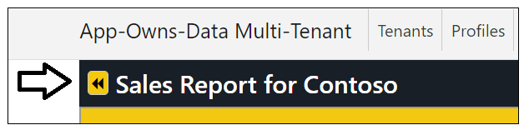

Now test clicking the **Embed** button for other customer tenants. As you can see, the **AppOwnsDataMultiTenant** application has the ability to acquire access tokens for any of the Azure AD applications that it has created.

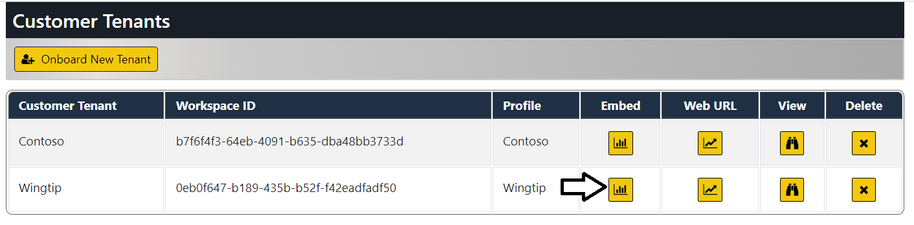

Xxxx

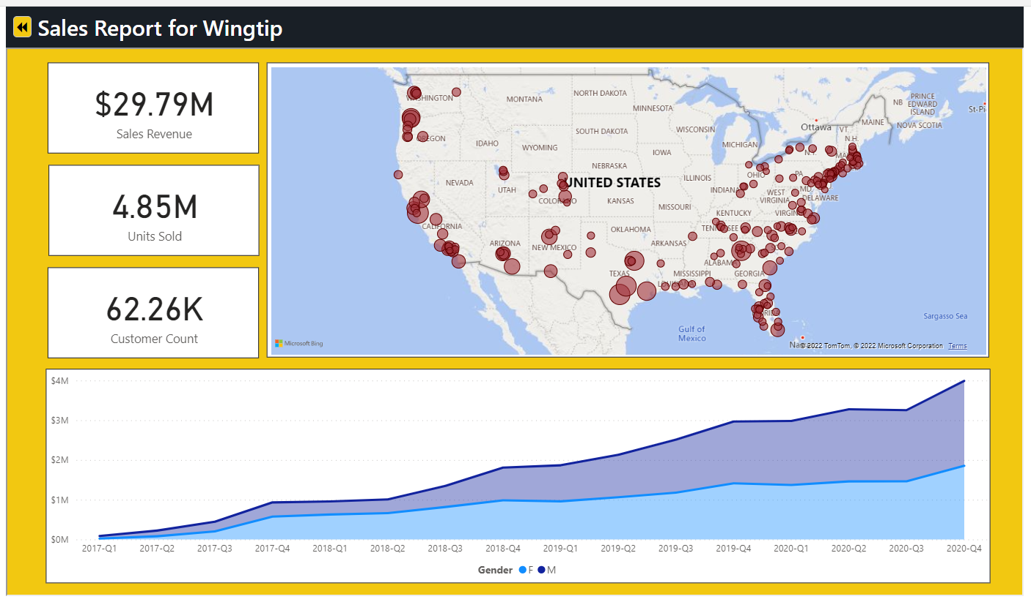

Xxx

Xxx

### Inspect the Power BI Workspaces

If you're curious about what's been created in Power BI, you can see for yourself by navigating to the Power BI Service portal at [https://app.powerbi.com](https://app.powerbi.com/). You should be able to see and navigate to any of the Power BI workspaces that have been created by the **AppOwnsDataMultiTenant** application.

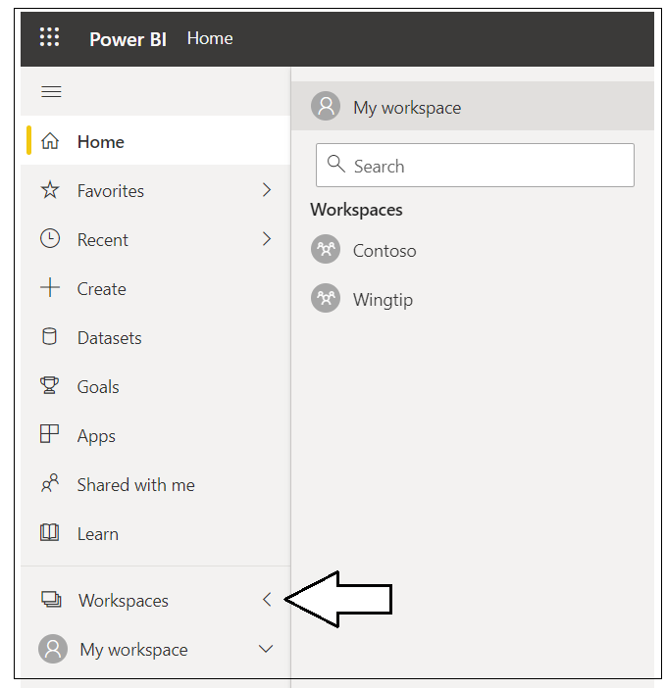

Navigate to one of these **workspaces** such as **Contoso**.

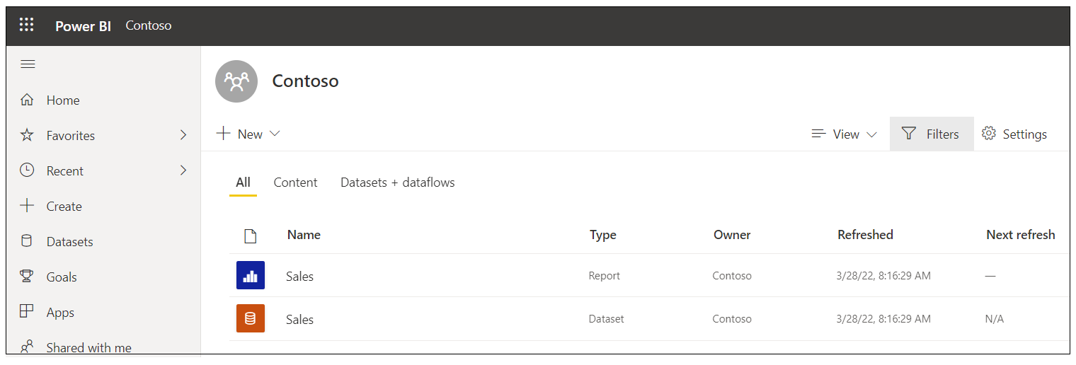

Xxxx

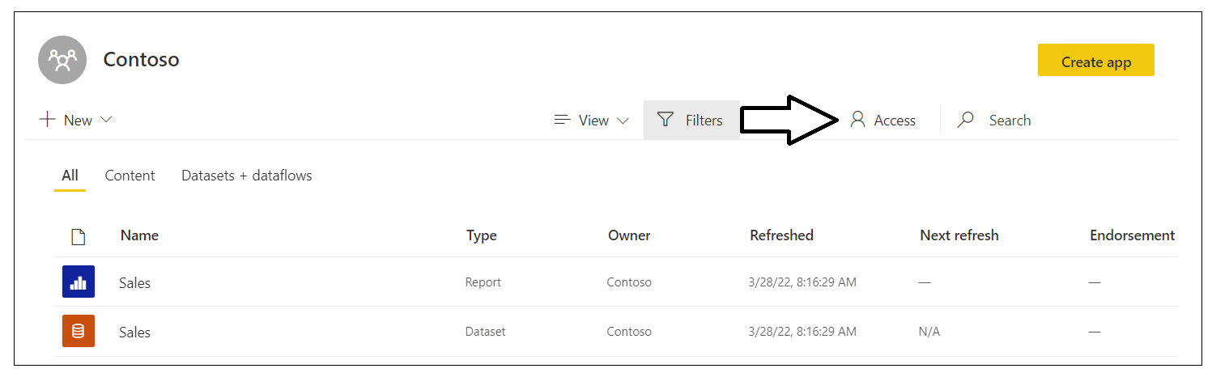

Xxx

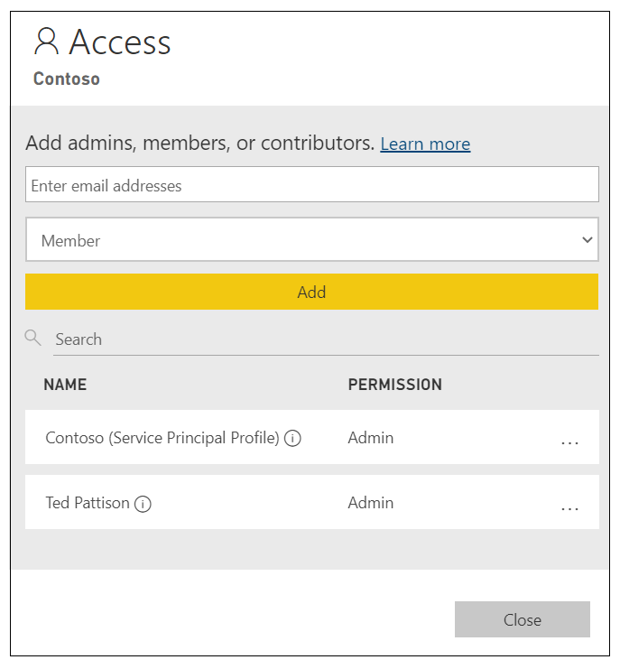

xx

Drill into the **Setting** page for the dataset named **Sales**.

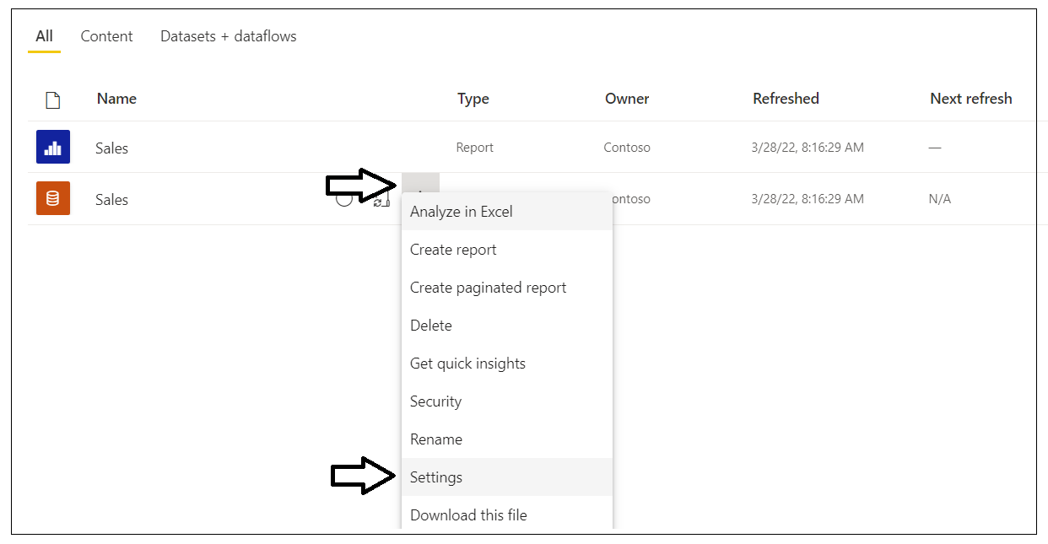

You should be able to verify that the **Sales** dataset has been configured by one of the Azure AD applications that was created by the **AppOwnsDataMultiTenant** application. You should also be able to see the **Last refresh succeeded** message for the dataset refresh operation that was started by the **AppOwnsDataMultiTenant** as part of its tenant onboarding logic.

### Create Multiple Workspaces with a Single Service Principal Profile

At this point you have used the **AppOwnsDataMultiTenant** application to pool app identities where one service principal can be the owner of multiple customer tenants. While this approach will work for many organizations and ISVs using Power BI embedding, you can take things one step further by creating a new service principal each time you create a new customer tenant. An application design which maintains a one-to-one relation between service principals and customer tenants will provide the most secure level of isolation. When you pool a service principal across tenants, that service principal will be the owner of datasource credentials for more than a single client.

When creating a new customer tenant using the **Onboard New Tenant** page, you can select the option to **Create Tenant using New Exclusive App Identity**. If you select this option, the **AppOwnsDataMultiTenant** application will create a new Azure AD application and then use the service principal from that application to create the workspace in Power BI.